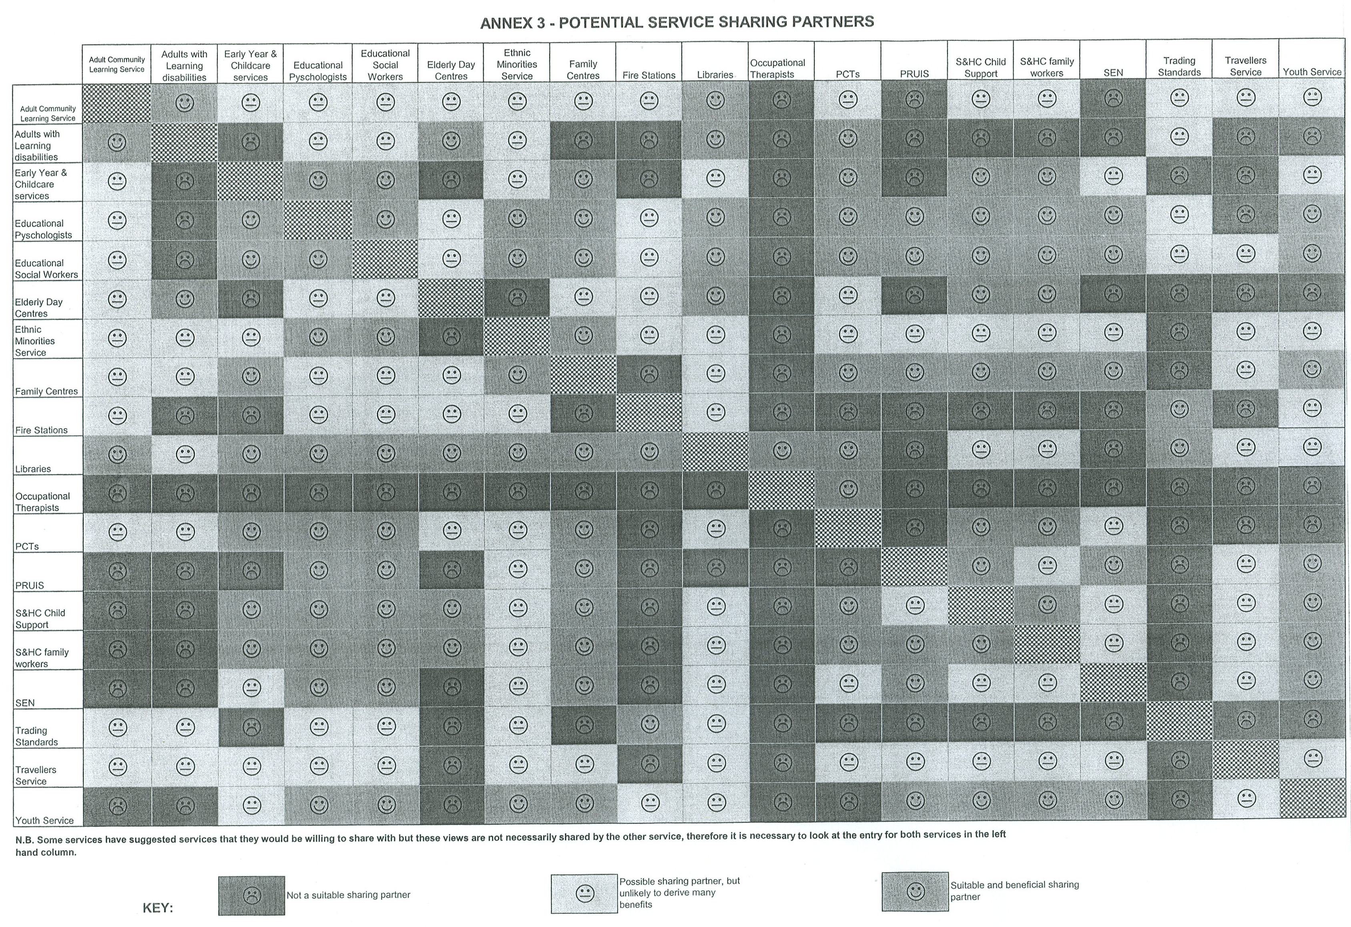
EX6 - page 17
ANNEX 3

