APPENDIX 1


Fire and Rescue
2009-10 Action Plan
Consultation
----
Report on group discussion

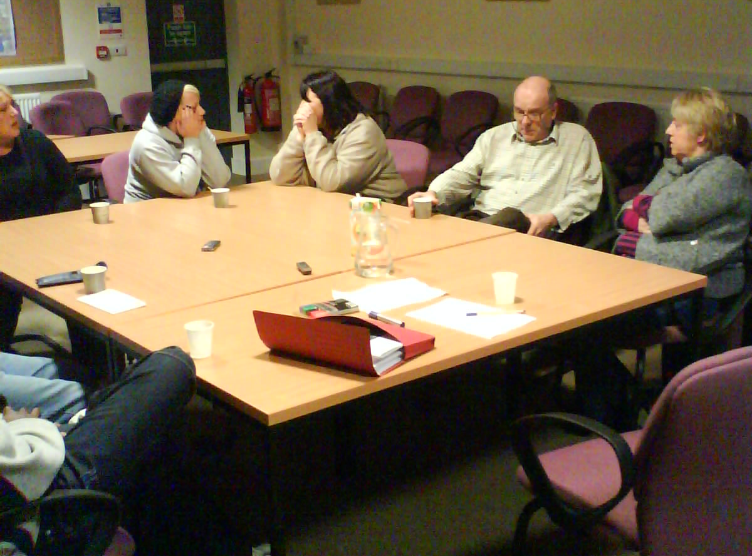

Prepared for:
Oxfordshire County Council

Prepared by:
Derek Mitchell
Alpha Research Ltd
01844 260248
derekm@alpharesearch.co.uk
www.alpharesearch.co.uk

January 2009

Contents

Background and Objectives 2
Management Summary 3
Findings 4
Current perceptions of the Fire and Rescue Service 4
Action Plan 5
Project One: Review of Prevention and Risk Reduction 6
Project Two: Review of the Implementation of the Fire Safety Order 7
Project Three: Working with the Requirements of the Local Resilience Forum 9
Project Four: Review of the Training Requirements and Operational Needs associated with Retained Duty Staff 9
Project Five: To achieve Level Three in the Local Government Standard for Equalities 10
Project Six: Review of the Joint Working Opportunities with the Emergency Planning Unit 11
Project Seven: Creation of a Succession Planning Strategy 11
Project Eight: Review of the Incident Command Structure and Gold Command Resilience 12
Action Plan priorities 12

Appendices [provided separately]:

Appendix 1: Research Methodology and Sample
Appendix 2: Screener for recruiting participants
Appendix 3: Participant letter
Appendix 4: Discussion guide

Background and Objectives

Oxfordshire Fire and Rescue Service (OFRS) has a statutory responsibility to consult on its five yearly Integrated Risk Management Plan (IRMP) and associated annual action plan. The five-year plan outlines the strategy for maintaining and improving the service and carrying out risk reduction work. The action plan includes details of the main projects proposed for the following year.

The five-year plan was consulted on and set last year and this report relates to the consultation carried out regarding the 2009-10 action plan. Qualitative research in the form of a group discussion with nine Oxfordshire residents was undertaken on 1st December 2008.

The key aims of this consultation were to:

- fulfil statutory requirements to consult on the annual action plan
- explore attitudes and perceptions of the Fire and Rescue Service
- identify public priorities
- inform future service delivery.

Full details of the methods used and the people involved are appended.

Management Summary

Oxfordshire residents who participated in this group discussion held OFRS in high regard, praising the professionalism and tenacity of staff in undertaking a difficult and dangerous job. They saw the fire service as primarily an emergency service designed to save lives and neutralise dangerous situations. Until they received a short introduction from OFRS, participants in the group discussion were less conscious of the preventative and educational role of the Service, or of how much it has to continually adapt to meet new challenges, such as changing patterns of traffic on the roads.

Participants were shown the proposed 2009-2010 Action Plan. They were able to review the projects based on their limited perceptions of certain aspects of the service, in particular remarking that they were not very conversant with the internal workings of OFRS.

In general, the action plan document was perceived to be quite abstruse and jargon-heavy in places. However, the projects proposed seemed sensible to the participants and all covered elements of the service that were seen as integral to OFRS and, in some cases, ripe for review.

The projects which were most supported were those which were perceived as (a) addressing the most important functions or roles of the service and (b) reviewing services with the most potential for improvement. Projects One and Two met both these criteria and were strongly supported by participants. All other projects were seen to be reviewing core roles of OFRS, but there was little perception of significant room for improvement in these areas. In spite of this, Projects Three and Four were still seen as important to undertake, whilst Projects Six and Seven were of lesser importance. Only Project Eight was seen by the majority of the participants as not worthwhile, mainly because the Incident Command Structure was believed to be highly effective already.

Findings

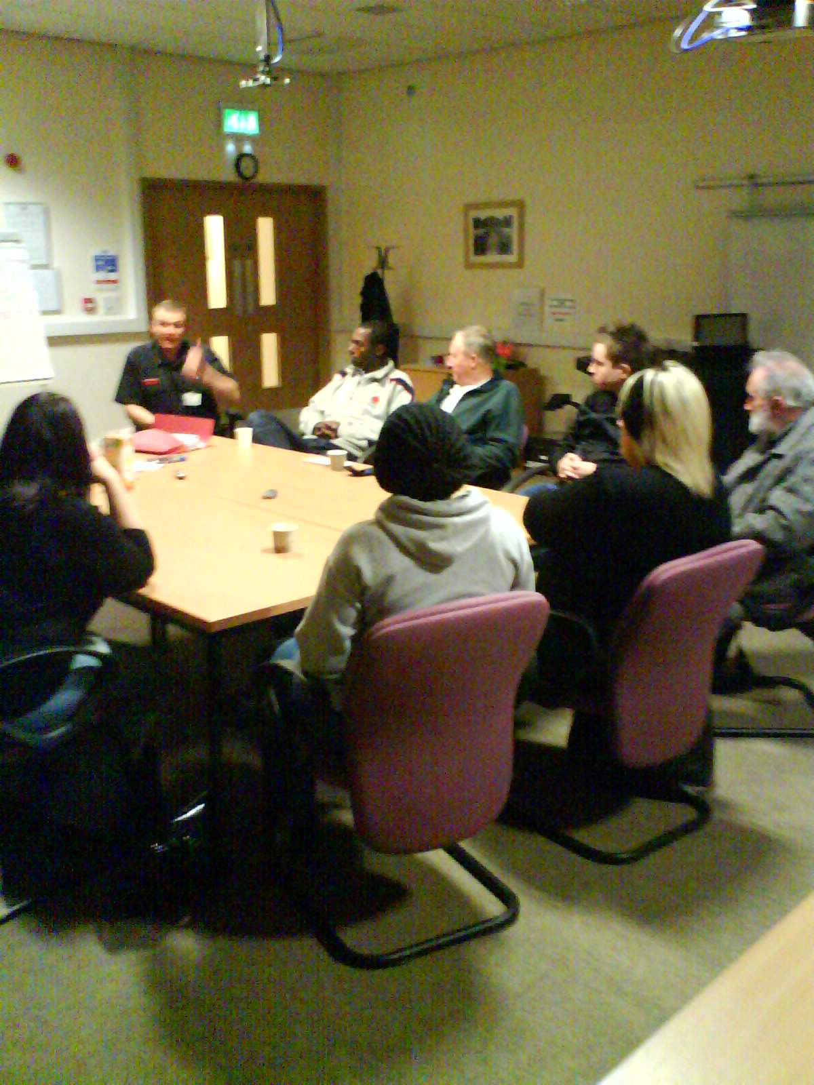

Current perceptions of the Fire and Rescue Service

Before given any background information, participants in the group discussion were first asked for their general impressions of fire and rescue services in Oxfordshire. The role of the service in saving lives and rescuing people from danger was uppermost in participants’ minds:

“The guys who come and save us”
“They are an emergency service first and foremost.”
Participant comments

The service and staff were regarded highly, for their professionalism, speed of response, courage and tenacity in helping and rescuing people from danger. Participants praised the attitude and dedication of staff to their work.

“They are not praised enough – it must be a hazardous job.”
Participant comment

It was recognised that they play a key role in attending road traffic accidents as well as fires. Reference was also made to the less dangerous aspects of their work, such as attending to cats trapped in trees or people caught in railings.

Only after they had been given an overview of the service, by Nick Bourke from Oxfordshire Fire and Rescue Service (OFRS), did participants recognise how central the work of prevention and education was in the fire and rescue services. However, they also commented on the limits of education to prevent incidents:

“You can lead a horse to water but you can’t make him drink.”
Participant comment

They became more aware of the need for the service to continually evolve alongside a changing society, for example in response to changing road conditions and traffic levels. The need to meet specified government targets for the service was also identified at this point, with participants remarking upon how much the service might be shaped by target-setting. Some saw targets as a potent tool for ensuring high standards of service, whilst others were a little concerned that too much emphasis on a ‘tick-box culture’ in the service might lead to targets which do not best reflect the current or future service required.

“If you don’t have a target you don’t know what you’re doing.”
“Government has targets which don’t necessarily reflect the job.”
Participant comments

Participants struggled at this stage to suggest any improvements to the way in which OFRS operates. They did, however, suggest that there may have been some consequences of the strike action in recent years:

“What’s their morale like after the disastrous strike a few years ago?”
Participant comment

There was also one call for more preventative work with the public in general and younger people in particular, and another for reassurance that any positive discrimination in recruitment is in the best interests of the local community.

Action Plan

Participants were shown the introduction section of the latest five-year Integrated Risk Management Plan for OFRS, before considering in depth the proposed 2009-10 Action Plan.

Projects in the Action Plan were explained [see Discussion Guide, appended] and then discussed by the group for five to ten minutes each. Participants were asked to consider the following six questions for each project:

1. What are your first thoughts on this project?
2. How clear is it to you what the project is aiming to do?
3. How important do you feel this particular review is? Why?
4. How much do you see it as a core part of the role of Oxfordshire Fire and Rescue Service?
5. How much is there a particular need for this part of the service to be reviewed?
6. What else could this project cover under the same title, that you feel could be worthwhile?

For most of the projects, participants felt that they were not able to give an expert opinion as they did not understand enough about the internal workings of OFRS. However, they were able to comment on how they perceived particular aspects of the service and so could comment on how important they felt particular reviews might be.

They also commented that the action plan was quite jargon-heavy and difficult for the layperson to understand in places.

Project One: Review of Prevention and Risk Reduction

Participants were clear regarding the overall remit of this project, although they did feel the description was too complex and not in plain English. They saw prevention and education as a central role of OFRS and because they did not know a great deal about it, they felt this might indicate a need for review to ensure heightened awareness of safer behaviours.

“It’s obviously better to prevent something than go there after the event.”
Participant comment

There was also some contention regarding the targeting of specific groups, such as younger drivers, or older people in the home. While most supported some focus on groups that were more at risk, others saw more scope for broader educational work targeting the wider public.

“I think everything should be aimed at everyone not just a specific group.”
“They haven’t got the money. You’ve got to put your money towards the best target groups that have come out in statistics. It’s the only way they can do it.”
Participant comments

The combination of perceived high importance of preventative work alongside potential areas for improvement meant that this part of the service was seen as ripe for review. Indeed, it was perhaps more strongly supported by participants than any other project discussed.

Participants suggested more workshops with target groups to instil safer behaviour.

Project Two: Review of the Implementation of the Fire Safety Order

The rationale for this project was reasonably clear to respondents. Working with businesses to enhance safety in the workplace, whilst also enforcing the law, was seen as a difficult balance to strike.

“We have four fire extinguishers that don’t work at our work, and no smoke alarms, and someone should make them do something about it.”
Participant comment

Participants worked in or knew of companies local to them that flouted fire regulations, so thought there must be considerable potential to improve safe behaviour of businesses and reduce risk here.

Again, this was seen as a core part of the OFRS role and an important part of the service to get right. The need for review was clear to participants, because it was an important area and there seemed to be untapped potential to improve the behaviour of businesses in this area.

“What do businesses need to do the right thing?”
Participant comment

Project Three: Working with the Requirements of the Local Resilience Forum

Ensuring effective strategies are in place in case of major emergencies had clear utility to participants. It was believed that threats of disaster were greater now than they have been, due to a perceived rise in terrorism and potential for flooding in particular.

“It’s very important in this day and age. Look at ‘9/11’ and all the firemen that were killed in that. And the Olympics coming up”
Participant comment

There was less clarity with regard to what this project might entail, because such contingency measures are not felt to be generally available in the public domain. However, participants did feel confident that OFRS and other agencies would be well prepared in the event of an emergency. They cited how well the flooding in the Oxfordshire area was handled in recent years, in particular the co-ordination of the response. This, along with the perception of how well the country in general seems to cope with major emergencies, seemed to suggest that communication strategies between and within agencies, in place for major emergencies, must be healthy.

“It is difficult to know if it will work until it happens.”
“If they can do it at a national level then they must be able to feed that expertise down to regional level.”
Participant comments

The fact that participants had confidence in this aspect of the fire and rescue service inferred to them that it was less in need of a review than the first two projects.

Project Four: Review of the Training Requirements and Operational Needs associated with Retained Duty Staff

This proposal, to review the training and competencies for Retained Duty Staff (RDS), was clearly understood by participants. Initial reaction was that this should be subject to continual review anyway and so perhaps is less in need of bespoke, ad hoc scrutiny. However, it was also clear that the effectiveness of RDS was vital to the success of OFRS and so anything which may be needed to optimise this should be welcomed.

“Surely this has been going on for years and it’s all finely tuned already.”
Participant comment

Participants had no feeling that RDS were insufficiently competent in their role, which might have enhanced the need for a review. They also commented that RDS should be well versed in what is required from them if they have two hours of training per week, as they currently do. Concern was expressed that a requirement for more than two hours of training per week for RDS might discourage new recruits.

Overall, this project was broadly supported because it was a core part of the service rather than because improvements needed to be made.

Project Five: To achieve Level Three in the Local Government Standard for Equalities

This project was discussed in less detail with participants because there is a statutory requirement to reach a certain standard for equality and diversity. As the review has to be done, participants were asked only if they had any general comments on it, or if there was anything else which this project could perhaps cover.

Some participants felt strongly that only the most competent people should be recruited, and that positive discrimination of particular demographic groups could be damaging to the overall competency of the workforce. Otherwise, no comments were made.

“Get the best people for every job. That’s all I care about.”
“If my house was on fire, all I’d care about is if they can deal with my fire.”

Participant comment

Project Six: Review of the Joint Working Opportunities with the Emergency Planning Unit

There was some lack of clarity initially over the distinction between this project and Project Three. With some more information, participants understood this project to be more focused on resourcing and expertise within Oxfordshire in the event of a major emergency, compared to the wider, regional remit of Project Three and its focus on chains of communication. However, it remained debateable to participants whether both projects would be necessary within the next year’s action plan, or whether they might be combined into a single review.

“It might be more expensive to review than the savings it could result in.”
Participant comment

As with Project Three, participants saw this as a core remit of OFRS, but knew very little about how well it is resourced at present. They did have faith that the systems were likely to be well set up in the event of a major emergency and so were not confident that there was any urgency for a review here.

Project Seven: Creation of a Succession Planning Strategy

Like Project Four, one first reaction to this project was that ensuring retention and development of staff should be subject to continual rather than occasional review. It was also difficult for some to feel qualified to comment.

“Projects Six and Seven concern things which only those who are in the business can know about. I don’t feel qualified to comment on this.”
“This is what it’s all about running a business. You have to do this all the time.”
Participant comments

Support for this project was mixed, with some remarking how fundamental it was to nurture staff and ensure that all levels of the service are fully populated by people with the requisite competencies. Others felt that this should happen

naturally as gaps appear in the organisation and that reviews should be unnecessary.

Overall, there was a modicum of support for this project.

Project Eight: Review of the Incident Command Structure and Gold Command Resilience

This was immediately seen as a core priority for OFRS. Participants saw that it was fundamental to ensure that the right number and calibre of staff attend and co-ordinate each incident, and that no-one is given too much responsibility or that senior staff are mobilised when they need not be.

They did struggle a little with the clarity of the description of the project:

“Whoever wrote this has got a degree in gobbledegook.”
Participant comment

Again, comments were made that the incident command structure should be subject to continual review, where each incident helps to shape and refine the future service provided. There also was not felt to be a deficiency in this regard, perhaps negating the need for a bespoke review.

“It’s an accumulation of experience. You can’t play the game with a rule book in hand.”
Participant comment

There was perhaps less support for this project than any other, although it was, in the participants’ eyes, clearly very important to the smooth running of the service.

Action Plan priorities

Once each individual project was discussed, individual participants were asked to record a score between one and five, where a score of one would indicate that they thought a project was not worth undertaking, and a score of five would indicate that they thought a review was very important.

The mean scores are shown in the table below for each project, along with how many of the nine focus group participants gave a score of 1,2 or 5 for each project.

The table indicates that the majority of participants felt that Projects One and Two were of particular merit to undertake, whereas the majority of respondents did not feel that Projects Six, Seven and Eight were very important to move forward. However, only in Project Eight did the majority of the group give the lowest score of 1, indicating that they felt it was not worth undertaking.

It should be noted that all projects were seen to be reviewing core roles of OFRS. Those given lower scores on average were thought only to be less in need of review.

Project | Mean Score Out of Five | Scores of  One | Scores of  Two | Scores of  Five
1 | 4.56 | 0 | 0 | 6
2 | 4.33 | 0 | 0 | 5
3 | 2.89 | 2 | 1 | 0
4 | 3.78 | 0 | 1 | 3
6 | 2.33 | 3 | 3 | 1
7 | 2.56 | 2 | 3 | 1
8 | 1.56 | 6 | 1 | 0
TABLE. Ratings out of five for project utility.

This year’s consultation was carried out with the guidance from the corporate core and the IRMP consultation guide issued from central government.

Consultation started from the 27th October 08 for a period of 12 weeks

Below is a breakdown of the responses from the consultation

Response Type | Responses | Additional Comments
Alpha Research | 9 | See Appendix 1
E-mail | 4
Total | 13

