ANNEX 2

General
The companies running the four cycle hire systems described below have been consulted as part of the feasibility study process. Each of the four companies has expressed an interest in providing an Oxford cycle hire pilot scheme. However, if Members decide to proceed with a pilot, the procurement process will be in accordance with appropriate procedures and it may be that other companies will also wish to submit a tender.

OYBike
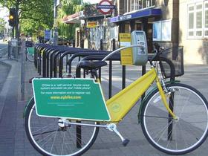
The OYBike System is a street-based rental station network that allows you to hire and return a bicycle via your mobile phone. The bikes are very robust, with shaft drives instead of chains, three gears, dynamo lights, a small basket on the front, a carrier at the back (with advertising panel) and puncture proof tyres. OYBike already hires out cycles in Hammersmith, Reading and Cheltenham with around 60 bikes at Hammersmith and 30 at the other locations. The OYBike service requires users to register beforehand. Registration is £18 per year. The first half hour ride is free, and after that charges are approximately £1 an hour.

The bicycles are secured to their bike stands using cables that are attached to the bicycle. These cables double as security locking cables when the bicycles are on hire. Each bike stand is equipped with a specially developed electronic lock operated through a battery powered key panel and LCD display. This lock holds the cable secure until that bicycle is rented out.
Registered users dial a phone number displayed on the rental station’s information screen. The phone number is actually the number for that rental station; so as soon as the call rings the rental station, the OYBike software system reads the telephone number of the phone making that call, hangs up without answering the call and validates that number against the database of registered users. OYBike rental stations can also be operated by smart card or proximity card.
For more details go to: www.oybike.com

Hourbike
The Hourbike system is currently being used for a pilot scheme in Bristol based on 60 bicycles. The system works with a battery powered key panel and locking device attached to each cycle parking stand. A simple SMART card is used with the member's PIN to release the bike from its locking device and start the rental period. Bicycles can be returned to any Hourbike stand. The rental period ends when the bike is returned and credit is deducted from the members account according to rental charges applicable for that location. The general approach is to allow the first 30 minutes free, however, Hourbike believes in specifying the tariff arrangements with the client according to local circumstances. Similarly, Hourbike offer a range of bicycle designs that can be customized to suit the local environment and any sponsorship deals etc.

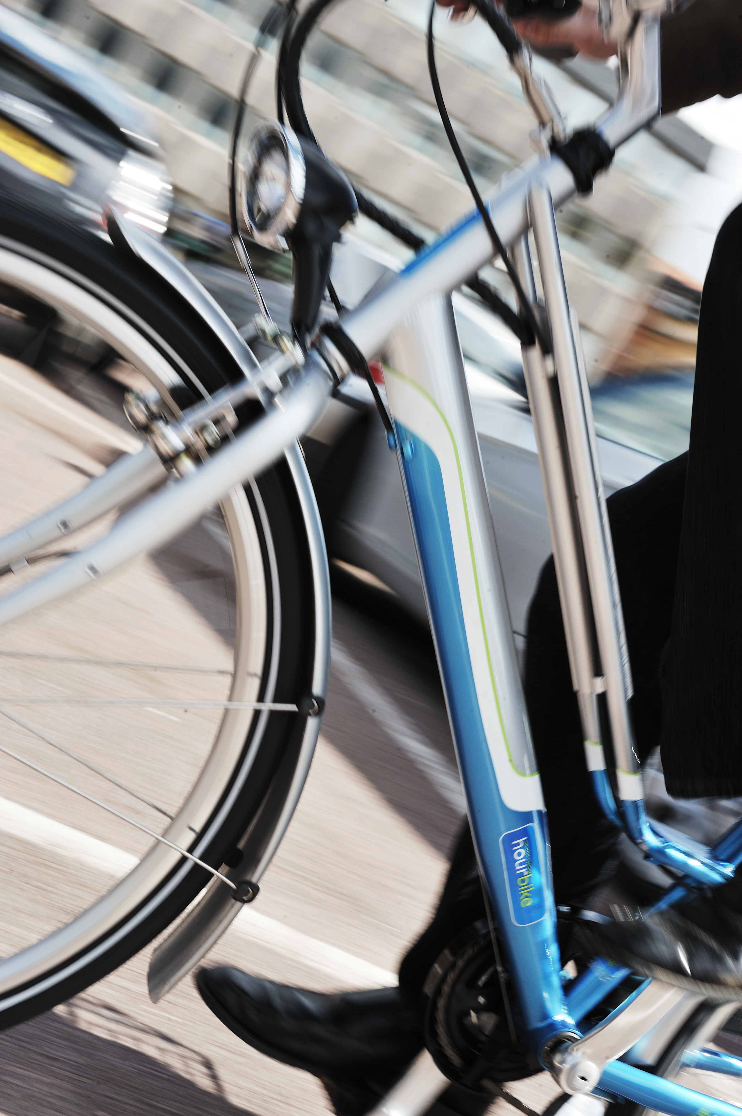

Hourbike uses GPRS technology to enable the automated hire and return of bikes. All rentals are automatically recorded centrally as they happen so that bike availability is always current on the Hourbike website. The system also allows for the collection of data about who is using the system at any given time.
For more details go to: www.hourbike.com
Smartbike

Smartbike is the cycle hire system operated by Clear Channel Outdoor (who currently have the bus shelter contract in Oxford). The company runs the Smartbike system in various cities in France, Spain, Sweden, Norway and the USA. Its flagship scheme is “Bicing” in Barcelona which boasts 400 parking stations and around 6000 bikes. The bikes have an attractive design with a locking connection near the handlebars.

Users of the system first have to register via the web, phone or city registration office. Once registered, you can type in your ID number at a parking hub terminal (or use your membership swipe card) to release one of the bicycles fixed to the parking bar. When you return your bike to one of the system hubs, it recognizes the bike and ID of the user. The electronic system of the terminal and parking bar requires a power supply which can add to installation costs. However, the system is easy to use and does allow for the collection of data about patterns of usage.
For more details go to: www.smartbike.com

Cyclocity
Cyclocity is the brand name for the cycle hire system operated by JCDecaux. The company runs cycle hire systems in various cities in Europe, most notably Paris and Lyon in France. Its flagship scheme is Vélib’ in Paris The system was launched in July 2007 with 10,000 bicycles and 750 docking stations each with fifteen or more bikes/spaces. This number has since grown to 20,000 bicycles and 1,450 stations, roughly one station every 300 metres throughout the city centre, making Vélib’ the largest system of its kind in the world.

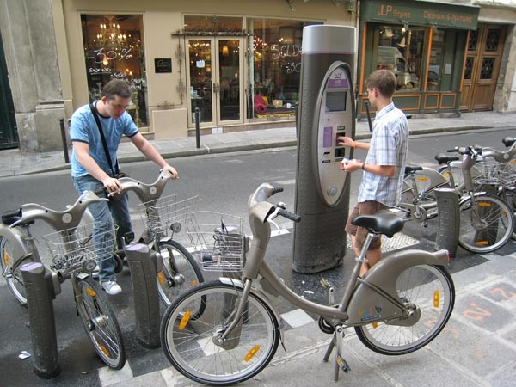

The Vélib’ system costs one euro for a day and 29 Euros for the year. Individual journeys which take less than 30 minutes are free. Short term users such as tourists can register to use the system at the ticket terminal adjacent to the parking stands. But all users need to give authorisation for 150 Euros to be deducted from the user’s bank account if the bicycle is not returned to a docking station. Once registered, you can release a bicycle from an individual stand using a membership swipe card. When returning the bike, the system recognizes the bike and ID of the user. The electronic system of the terminal and individual stands requires a power supply which can add to installation costs. However, the system is easy to use and does allow for the collection of data about patterns of usage.

For more details go to: www.jcdecaux.co.uk/development/cycles

