Additional appendices to statutory information

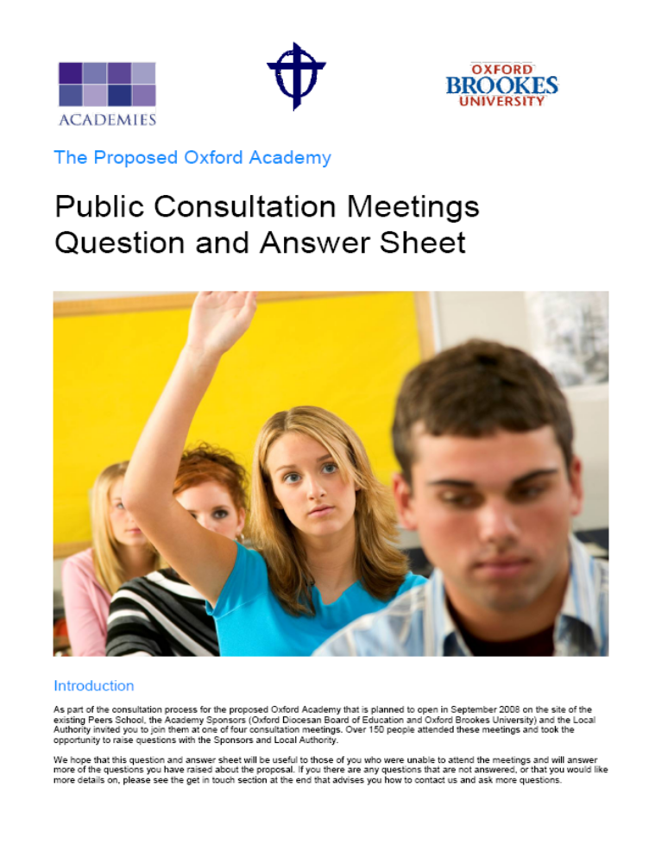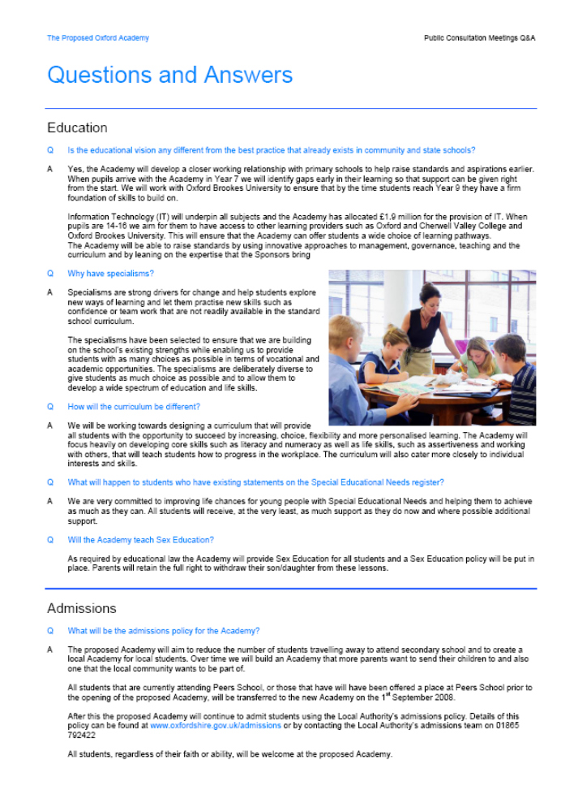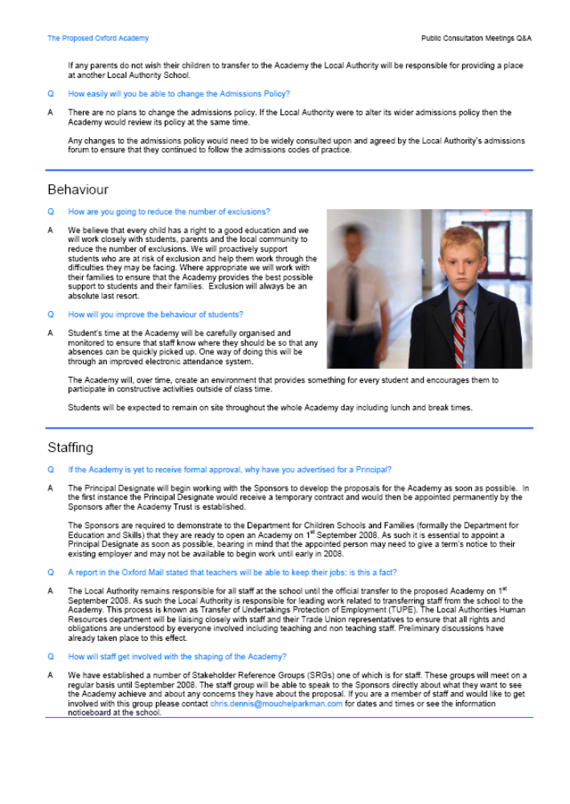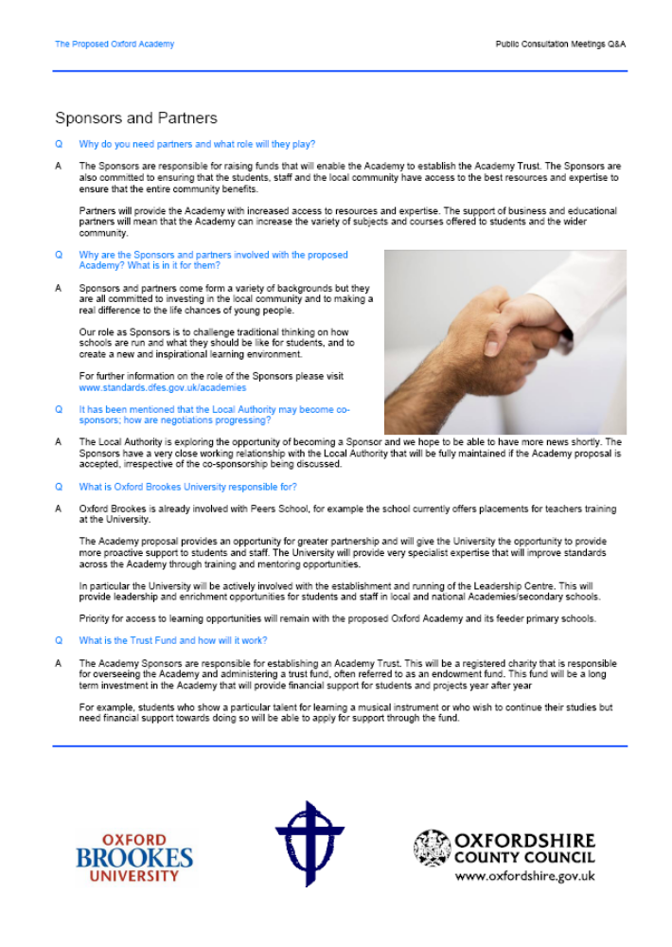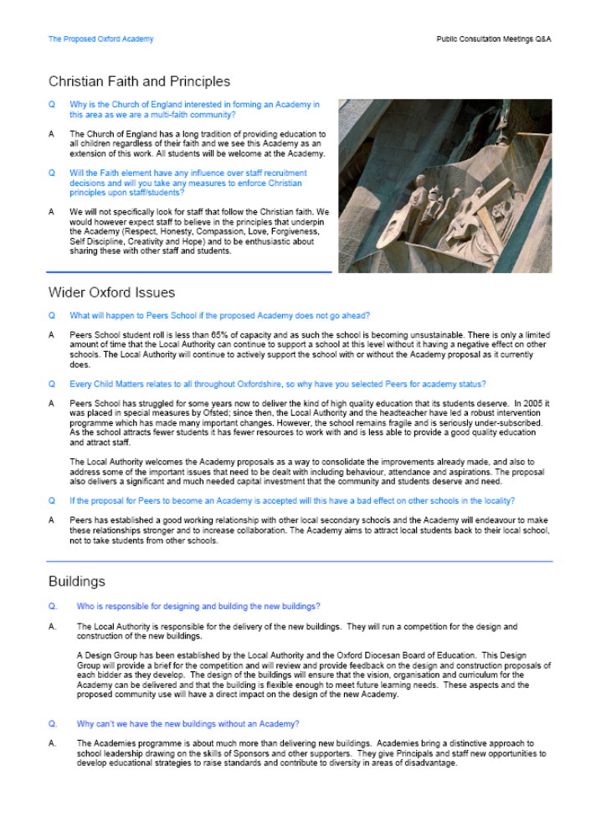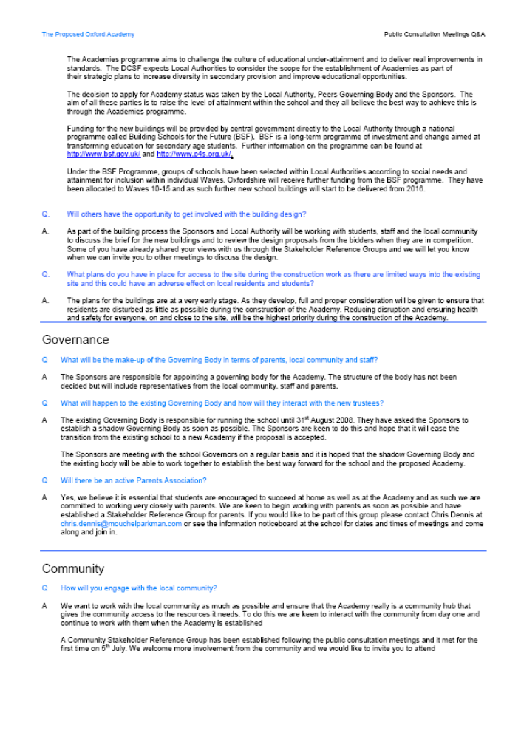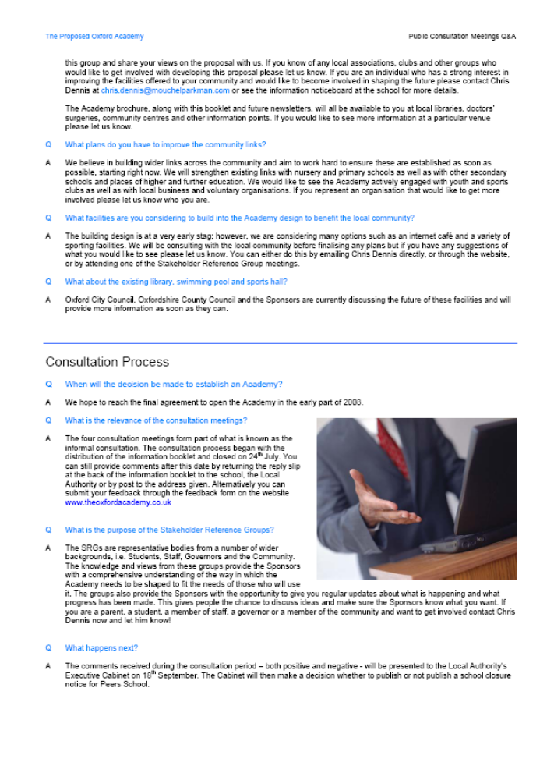

Appendix D: Letter from LA to Peers School Staff

 | 
To all staff at Peers School  Re: The Academy Proposals | Jim Crook  Interim Director for Children, Young People & Families  Judith Morris  Head of Educational Effectiveness Service
To all staff at Peers School  Re: The Academy Proposals | Educational Effectiveness Service  The Cricket Road Centre  Cricket Road Oxford OX4 3DW
To all staff at Peers School  Re: The Academy Proposals | Telephone: (01865) 428084
To all staff at Peers School  Re: The Academy Proposals | Fax: (01865) 428088
To all staff at Peers School  Re: The Academy Proposals | Date 3 May 2007
Dear Colleagues,

I am writing to give you a quick update on where we are with consideration of the possible closure of Peers School and the opening of an Academy.

The ‘Expression of Interest’ (EOI) which drew on the visioning work of staff and governors of the school and of the Sponsors has been approved by the Department for Education and Skills (DfES). As previously explained, this means we have permission to begin work in the ‘Feasibility’ phase, to investigate how possible it is to establish an Academy on the Peers School site.

The proposal is for an Academy offering specialisms in ‘Sport’ and ‘Mathematics & ICT’ and designed for 1050 students in Years 7-11 and 250 sixth-form students. The Academy would be open to all local students with no preference given to students of any particular faith. There will be no change to the Local Authority (LA) admissions procedures at Year 7. Education would continue to be free to all students and would be funded directly by the DfES. The lead Sponsor is the Oxford Diocesan Board of Education, with whom we have had a long-standing and effective working relationship. Oxford Brookes University will be a co-sponsor. If approved, the school would close on 31 August 2008 and the Academy would open on 1 September 2008, moving to newly or substantially rebuilt premises on 1 September 2010.

The DfES have appointed Mouchel Parkman to project manage the feasibility phase. The Project Managers Chris Dennis and Kiran Gondal will be your first point of contact for questions related to the project. The Sponsors have appointed an Education Adviser who is Roy Blatchford. His role is to work with strategic partners towards expanding and further developing the educational vision that was incorporated within the EOI to produce an outline plan for student learning provision and for raising achievement in the proposed Academy.

In parallel with this the LA has appointed a project manager to work on the practical issues about the site and the plans for a new or substantially new building to meet the needs of the Academy, should it be approved. The firm of consultants Hewitt Freeborn has been selected as the LA’s preferred choice, subject to contract.

A PSG (Project Steering Group) has been set up. The membership includes the Chair of Governors, the Sponsors, the LA and the DfES. It has met twice recently. They are the decision-making body relating to the way the Academy proposal shapes up. A Principal Designate for the proposed Academy will be appointed through an open process. The school’s Governing Body has requested that a shadow Governing Body be appointed as soon as possible. Progress is being made towards agreeing a way forward on this, so that the leadership of the Academy is in place, should the decision to close the school and to open an Academy be finalised.

The Sponsors and the LA have been talking to a range of partners about how they can add their support and expertise for the benefit of the school now and in the future. A range of exciting opportunities are developing with Oxford Cherwell Valley College, BMW and Oxford United Football Club, for example.

I have written a letter to parents (attached) to explain that if permission is granted by the LA at the meeting with Councillor Michael Waine on 4th June, a series of informal consultations will take place so that people can feed their ideas into the formulation of plans. Staff and members of the wider community are encouraged to participate and will be most welcome at these meetings.

In addition to the scheduled meetings, within the informal consultation period of six weeks, further information about the proposals will be circulated and further meetings will be arranged with staff, students, governors, parents and the community. During this time you will also be invited to make written comment on the proposals that will be considered by the County Council’s Cabinet before they make any decision on school closure or the issuing of a school closure notice. If a decision is made to issue a school closure notice, a further six week consultation period will follow in which comments can be made. We will ensure that this period will not fall within school holidays.

As you will know, Tom Long is our LA HR colleague who will be your first point of contact about TUPE arrangements (tom.long@oxfordshire.gov.uk) and who has already had contact with groups of staff and unions. Chris Dennis should be the first point of contact if you have general queries about progress or the process involved in deciding on school closure and the establishment of an Academy (chris.dennis@mouchelparkman.com).

All of us involved in developing the proposals are committed to involving staff and students in contributing to the development of the vision for the proposed Academy on a more intensive ongoing basis so that the curriculum offer and premises meet the needs of children and young people and the local community.

I have asked Lorna if I can attend one of your staff briefings, so that I can add any further detail and attempt to answer any questions you may wish to ask. I know that answers to the initial questions from staff are being prepared by the Sponsors and the LA and will be with you soon.

Yours sincerely

Shannon S Moore Assistant Head of Service: Learning and Achievement, Educational Effectiveness Service.
Appendix E: Letter from LA to Parents of Peers School Children

To Parents and Carers of  children and young people at Peers School | Jim Crook  Interim Director for Children, Young People & Families  Judith Morris  Head of Educational Effectiveness Service

Educational Effectiveness Service

The Cricket Road Centre
Cricket Road Oxford OX4 3DW
 | Telephone: (01865) 428084
 | Fax: (01865) 428088
 | Date: 5 May 2007

Dear Parent or Carer,

PROPOSAL FOR THE ESTABLISHMENT OF AN ACADEMY:
YOUR VIEWS

We are writing to let you know as early as possible that we hope to consult parents in the near future about proposals to open an Academy on the Peers School site.

Background

You may be aware that Oxfordshire County Council, the Oxford Diocesan Board of Education and Oxford Brookes University have been working closely with Peers School to look at the possibility of establishing an Academy at the School site in September 2008.

The proposal is to open an Academy for 1050 students in Years 7 -11 and 250 sixth form students. The Academy would offer specialisms in ‘Sport’ and ‘Mathematics & ICT’. The Academy, like the existing school, would remain open to all local students, with no preference being given to students of any particular faith. Education would continue to be funded by the Government and be free for all students. The Academy would continue to adhere to the existing admissions arrangements and aim to attract local students to join.

If the proposal goes ahead it would mean that Peers School would officially close on 31 August 2008 and the Academy would open in the existing school buildings on 1 September 2008 with a new purpose built Academy building being ready for use in September 2010.
Your views

On 4 June, from 12.00 to 14.00h in Room 2 of County Hall, Councillor Michael Waine, Cabinet Member for Schools Improvement, will be asked to use his delegated powers to consider granting approval to us to carry out a formal consultation about the proposals for the school. If approval is given we will send you more information about the proposals.

In the meantime, assuming approval to consult will be given, we have arranged four public meetings to which you are warmly invited. Representatives from Oxfordshire County Council and the Oxford Diocesan Board of Education will be there so you can find out more about the proposals and ask any questions you may have.

Please come to one of the meetings and let us know what you want, share your views, ask questions and make sure you play an active part in improving the life chances of young people and adults in the local community.

Date and Time | Place
Tuesday 12 June 2007  5.00pm to 7.00 pm | Blackbird Leys Community Centre  Blackbird Leys Rd Blackbird Leys, Oxford OX4
Thursday 14 June 2007  7.00pm to 9.00pm | Rose Hill Community Centre  The Oval, Rose Hill, Oxford OX4 4UY
Monday 18 June 2007  4.30pm to 6.30pm | Peers School  Sandy Lane West, Littlemore, Oxford, OX4 6JY
Tuesday 19 June 2007  3.30pm to 5.30pm | Pegasus School  Field Avenue, Blackbird Leys, Oxford OX4 6RQ

The consultation process is your opportunity to get involved i.e. to find out more about the Academy proposal, how you can influence the process and to help us to develop future secondary provision on the Peers School site.

If formal consultation is approved, we will send you more information about the proposals and other ways you can make comments and get involved. In the meantime please find enclosed some general information about Academies.

Kind Regards

Shannon Moore
Assistant Head: Learning and Achievement
The Educational Effectiveness Service
Oxfordshire County Council
Appendix F: Primary Headteachers

Mr Chris Phillips  Orchard Meadow Primary School  Wesley Close  Oxford  OX4 6BG | Jill Hudson  Pegasus Primary School  Field Avenue  Blackbird Leys  Oxford  OX4 6RQ
Maureen Thompson  Windale Primary School  Windale Avenue  Littlemore  Oxford  OX4 6LS | Mrs Jenny Lee (until 31/08/07)  John Henry Newman School  Grange Road  Littlemore  OX4 4LS
Mrs Susan Mortimer  Rose Hill Primary School  The Oval  Rose Hill  Oxford  OX4 4SF | Mrs Josephine Millham  St John Fisher  Sandy Lane West  Littlemore  Oxford  0X4 6LD

Appendix G: Consultation Strategy

(Agreed by the PSG in March 2007)

- Consultation Overview

Introduction
It is a requirement of the Academy feasibility stage that full consultation is undertaken with interested parties. Prior to submitting the Funding Agreement a report must be submitted to the Secretary of State detailing and demonstrating the completeness of the consultation process and reporting the views of stakeholders and the local community on the proposal to establish an Academy.

Three types of formal consultation will be undertaken (i) to close the existing school (ii) on the proposal to establish an Academy (iii) in relation to the development of new buildings for the Academy. Across all three areas there will be consultation opportunities that will provide stakeholders with the opportunity to share their views and contribute to the development of the academy proposal as well as opportunities for the project team to keep stakeholders up to date with the progress that is being made.

The Oxford Academy Project
During feasibility all communication will carry the name “Oxford Academy Project”. During the feasibility the communications should always refer to the ‘proposed Academy’ to acknowledge that the Academy will only be established after a full consultation process has been completed.

A launch event will be organised following the signing of the Funding Agreement /when the Academy opens. This event will be the formal launch to the public and media, and a chance to promote the Academy. It may also be appropriate to have a closing event for the Peers school.

Consultation Requirements and Programme
Table 1 gives an overview of the activities that will happen as part of the consultation process. Sections 2, 3 and 4 then give more explanation of the different components of the consultation process and the activities within each component.

Section 5 lists all of the stages for the consultation required for this Academy, in the order in which they will occur, and with the approximate dates when each will occur. As the consultation process progresses dates will become fixed and the different sections will be completed. This will be recorded in Annex 1 – for the statutory closure consultation – and Annex 2 – for full consultation. Both of which will be updated and re-issued periodically to record progress.
Table 1: Overview of Full Consultation Process
Level | Activity | Purpose | Actions
Statutory | School Organisation | Consultation required to close the existing school | - Direct consultation with existing students, staff, parents, governors and the local community – information and public meetings  - Statutory Notices to be issued  - Agreement of Local Authority Executive to close the existing school
BSF | Building | Ensure the buildings are fit for purpose | - Local people to be consulted on the proposals for the buildings of the academy;
Formal | Admissions | Consultation of the LA and of its Admissions Forum before submission to the Secretary of State. | - Admissions policy to be agreed with LA.  - Consultation with parents and other schools  - Proposed Admission policy to be agreed with Admission forum and DfES Admissions Team
Formal | SEN Policy | Consultation with the LA SEN officer and existing school | - Head of SEN to be consulted (LA and School)  - Parents of SEN students to be briefed
Formal | Stakeholder Reference Group 1: Staff, Governors and TU’s | Keep updated on progress and take on board concerns as they surface | - Establish a group that will meet at least once every 6 weeks during the feasibility phase to discuss concerns and progress  - This group will then be responsible for feeding back to others
Formal | Stakeholder Reference Group 2: Parents and community | Keep updated on progress and take on board concerns as they surface | - Establish a group that will meet at least once every 6 weeks during the feasibility phase to discuss concerns and progress  - This group will then be responsible for feeding back to others
Formal | Stakeholder Reference Group 3: students | Establish involvement likes/dislikes, aspirations for education, buildings, answer questions and concerns, build momentum | - Meeting with the student council at least every 6 weeks during the feasibility phase to discuss progress and views on specific issues  - Meet with a group of students in each year for 1 hour consultation session
Statutory /informal | Consultation  (school closure) | A programme of formal meetings for key groups of stakeholders (community / parents etc) to hear and comment on the proposals to establish the Academy. | - Meetings to be jointly hosted by the Sponsor and LA with facilitation from the PM is required  - Meeting to be recorded and followed up with public newsletter (good practice)
Informal/ Good practice | Brochure (and poster to advertise meetings) | To support the process there will be a good quality brochure that explains the proposals under consideration | - Produce and distribute brochure for consultation  - Produce and distribute poster and newspaper / radio advertisement for the meetings
Good Practice | Update letter (LA/ school) | Ensure those directly effected are aware of progress and how they can contribute | - Letter to parents, staff and Governors to let them know when the school closure notice has been posted and the next 6 weeks consultation period
Good practice | Staff information | Keep staff in the loop –increase certainty and security | - Working in an Academy Guide  - Contact email address for questions  - Responses to questions as raised  - Staff information booklet
Good practice | Sponsors and partners | Build a sense of team and purpose, keep everyone up to date with progress, roles and responsibilities | - Informal presentations combined with breakfast, lunch, drinks informal socials
Good practice | Press releases | Active and reactive to ensure the real message is getting out and reduce confusion | - Official press releases and responses to questions as required
 | Launching the Academy | Event for stakeholders and media. | - Event to be planned when Funding Agreement signed/ when the Academy opens

- Statutory Consultation

School Organisation
Consultation is required to close the existing school and this is the responsibility of the Local Authority. Activities connected to the school closure will take place in May and June in tandem with the consultations on the proposals to establish the Academy. Following the informal consultations the Local Authority will publish Notices of Closure which will stand for 6 weeks during June and July. School Organisation Committees (SOC) will be abolished on 25th May and as such a meeting of the Local Authority Cabinet will be organised in September 2007 that (subject to the comments received) will issue the School Closure notice and a letter to parents, staff and governors to explain what it means. A second six week consultation period will then follow and responses will be submitted to the Local Authority Executive Committee for agreement to close the school. The final decision to close the school and open the Academy is then subject to approval by the Secretary of State agreeing to establish the Academy.

Planning
For this academy, in common with all future academies, the provision of the new or refurbished buildings will take place through the Building Schools for the Future Programme. This has a timetable separate from that of feasibility. The achievement of outline planning permission will therefore not be a condition for achieving Funding Agreement. Consultation for planning purposes will therefore be a separate exercise, although it may occur in parallel with consultation for school closure and to establish the academy.

Admissions
The Admissions Policy needs to be agreed in principle with the DfES and should follow the Academies model policy.

Consultation should then follow the ‘Code of Practice on Admissions’. It is normal practice that the Admissions Forum would be consulted on the proposals.
The Consultation with parents and pupils will also report on and seek views on the proposed Admission Policy. See section 3.2 for details. Special Educational Needs (SEN).

The proposed SEN policy needs to be drawn up and then there needs to be consultation with the LA’s Head of SEN and relevant officers/professional groups and parents. See section 3.2 for details. The SEN Policy should follow the Academies model policy.

- Formal Consultation

Stakeholder Reference Groups
Three Stakeholder Reference Groups (SRG’s) will be established ((i) staff and governors, (ii) parents and community (iii) students) and comprise of representatives associated with the development of the Academy or which could be affected by it.

The SRG’s should have a key ‘gate keeping’ role for the consultation of the community. The group will be consulted at the development planning milestones and their views will be fed through to the Project Steering Group (PSG) for discussion and final decision-making.

Key to the functioning of the SRG’s will be the ability of members to communicate with their constituencies where appropriate both on key issues which require formal consultation and where there are opportunities to ‘sound out’ views and aspirations prior to, and sometimes in place of, more formal consultation. They also have a key role in identifying concerns which arise from time to time in the constituency groups and allow these to be addressed.
Its Key Tasks will be:

- To act as the gateway for consultation with specific stakeholder groups in the community;
- To act as the mechanism for the broader discussion of Academy developments leading to views being reported to the PSG;
- To identify concerns exercising the various constituencies and allow them to be addressed in a timely fashion;
- To provide advice on views of the stakeholding groups to the PSG;
- To act as a key channel for the conduct of formal consultation;
- To monitor the effectiveness of communication with stakeholders on developments in the project.

The SRG’s should have representatives of parents of students from the School which will close to become the new Academy and other neighbouring primary schools; staff from the Schools directly affected and feeder primary schools; and local community representatives. It is intended that the SRG should identify other individuals and groups which should be represented on the SRG – or be invited to join ad hoc specific consultation groups - so that it can make sure that everyone who should be represented is included.
In undertaking its remit the SRG’s will, as appropriate, set up ad hoc specific groups to meet and discuss issues which arise. These groups will normally have a short lifespan.

A programme of meetings will be produced to allow the SRG’s to contribute to the formulation of polices for the Academy and to test out design proposals. Initially meetings are likely to occur 4 -6 weekly basis, but as the project proceeds meetings may become more/less frequent.

Other Consultations
In addition to good practice, it is a requirement of the Academy feasibility stage, prior to the signing of the Funding Agreement, for the proposals to be sufficiently consulted on with interested parties. Before submitting the Funding Agreement a report needs to be submitted to the Secretary of State detailing and demonstrating the completeness of the consultation process.

As well as the general meetings, there will need to be more formal consultations on the proposals to establish the Academy, so that a report can be made to the Secretary of State on the degree of support for the Academy.
The views of different groups will need to be obtained including:

- Parents;
- Students;
- Staff and Governors
- The Local Authority and City Council;
- Community Groups;
- Partners and Sponsors;
- Parishes;
- Primary Feeder Schools;
- Local Secondary schools;
- Colleges / Other Further Education Organisations;
- LSC
- Other local agencies; e.g. Health Trusts; libraries
- Public;
- Local businesses and existing site users
- Local councillors/politicians;
- Organisations with an interest in the Academy specialisms e.g. local Sports Clubs

These consultations will take place during May and June 2007, with the consultations with parents, staff and governors of Peers school also being scheduled to take begin in April and continue to July.

- Informal/Best Practice

To support the consultation process, there should be good quality information available to those who wish to have it.

Brochure

Purpose and objectives
- To introduce the proposal to create the new Academy to the community;
- To build the credibility of the Academy with parents and within the community;
- To answer the immediate questions that stakeholders may have;
- To be a supporting document for the consultations;
- To provide information on points of contact for any queries;

Layout and language
- Information and language that will be understood, valued and appreciated by all audiences/stakeholders e.g. concise and simple;
- Ensure that it will be read – inviting colours and images, short and sharp, key information;
- Positive pictures and images that reflect the ethos of the new Academy and inspire the audience;
- Use of Logo and other means to ensure the brochure is clearly linked with its sponsors;

Audience
- Those for whom the Academy plays a key role e.g. children and young people; teachers; parents; Learning Skills Council;
- Those involved in community affairs e.g. MPs/councillors, business leaders, the local authority;
- Other interested members of the community e.g. local businesses; teachers/parents/young people at other local schools; local residents; community groups;

Distribution
The brochure will be distributed to the following in May 2007
- Parents, Staff and Governors of Peers School
- Local Libraries;
- All Oxford head teachers;
- All Oxford school Chairs of Governors;
- All local Councillors;
- Internal Heads of Department at the LA and Oxford City Council;
- Neighbouring LAs (to Directors of Education)
- Trade Unions;
- Existing site users
- Community Councils
- Other community groups identified by the SRG’s;
- Mayor, councillors, local MP’s
- Learning and Skills Council;
- Parishes
- Partners and Sponsors

Launch Event
A launch event will be held following the signing of the Funding Agreement / when the Academy opens. An event to close the existing school and celebrate the work that the Academy will build on will be considered for Summer 2008.

- Consultation Programme

Tables 2 and 3 give the consultation stages for, respectively, the feasibility and implementation stages of the project. Most of the timings given are indicative. As the project progresses and stages are completed and dates arranged for other events the summary programme included at Annex 1 will be updated and periodically re-issued.

Table 2: Feasibility Stage Consultation Programme
TYPE | EVENT | DATE | Audience | NOTES
Good Practice | Presentations / discussions with existing Governors on Academy Proposal | 29 March 2007 | Peers School Governors and Headteacher | Prior to issuing the consultation brochure Governors and the Head were provided with details of the process (in addition questions raised by staff were collected for answering)
Formal | Decision by Local Authority to consult on closure prior to publishing statutory notices | March 2007 | School and community
Brochure and posters | 1. Publish Academy Marketing Brochure and letter to parents, governors and staff advertising the meetings in May on establishment and closure  2. Publish brochures to other stakeholders | May 2007  May 2007 | Parents and stakeholders | Brochure will include closure proposal as well as establishment of Academy.  Press notice in local papers will be published and posters will be circulated to raise public awareness
Good Practice / Formal | Initial Meeting with Trade Union Reps  - Presentation outlining the Marketing Brochure proposals, in particular the programme and the formal staff consultation process (proposed to start ahead of the Implementation stage | May 2007 | Trade Unions | Local Authority and Sponsor representative to provide overview of proposals and staff consultations
Formal | Public Consultation Meetings: 4 public meetings will take place in various locations to provide the maximum number of opportunities to attend  Other meetings will be held with school governors and school staff.  To discuss academy proposals published in marketing brochure. And to discuss school closure | June 2007 | Parents and key stakeholders | Joint presentation with LA.  Deadline for comments 24th October
Good Practice / Formal | Interviews and presentations with key stakeholders in local community and presentations  This may include:  Headteachers  Local Authority /City Councillors  LSC/Other educational organisations  Opposition groups | May/ June 2007 | Key stakeholders | As the Academy will have a sixth form, we will need to involve the local LSC who must be part of any consultation process. Information will be sent to LSC representatives at the same time as other stakeholders and extra meetings will be called as required.
Statutory | Consideration by Local Authority of decision to publish statutory closure notices | Summer 2007 |  | 2 weeks after closure of consultation
Good practice | Academy / School open day/evening for new students | September 2007 | Year 6 students and parents | More information for parents considering sending children to the Academy /School
Statutory | Statutory consultation process following publication of statutory closure notices | September –October 2007 | Public | 6 week notice period needs (ideally in term time)
Formal | Report to DfES (Project Lead) on outcome of consultations re proposal to establish the academy | October –November 2007 | DfES Academies Group
Formal | Consideration of Closure decision by Council Executive | October –November 2007 | Executive | Date to be agreed with Local Authority
Academy Process – good practice | Academy Stakeholder Reference Group meetings | 4-6 weekly | Stakeholder Reference Group members – and through them wider community

Table 3: Implementation Stage Consultation Programme [TO BE ADDED BEFORE IMPLEMENTATION PHASE COMMENCES]
TYPE | EVENT | DATE | Audience | NOTES
Brochure | Issue of Academy Prospectus  - Detailed information regarding the Academy Development. | Spring 2008 | Parents and key stakeholders
Good Practice / Formal | Staff Consultation  - Curriculum and school Organisation  - Proposed Staffing Organisation  - TUPE / legal rights ,etc | January –July 2008 | School staff & Trades Unions | Note 1
Statutory | Local Admissions Forum ( LA )  - Consideration of admission arrangements |  | Admissions forum | Note 3
Good practice | Student consultations, parents evening, open day | January 2008 – July 2008
Good practice | Public newsletter | October 2007– July 2008
Good Practice | School closure | July 2008

NOTE 1 - Staff Consultation
- There are specific legal requirements in respect of the TUPE or other requirements for transfer of staff. There is a ‘good practice’ issue in this regard. Staff are usually entitled to a minimum of 90 days consultation and lead in for change / transfer. Good practice suggests a significantly lengthened process which engages with staff positively at a significantly earlier stage. This normally falls within the Implementation Phase (post-Funding Agreement) but in this case will need to start pre-Funding Agreement.
- The Local Authority will be responsible for leading on the TUPE work with staff that will include providing staff, Trade Unions and the Sponsor with a TUPE timetable that details that work that will be completed.
- The Sponsor will be responsible for answering specific questions that are related to working at the Academy such as those related to the proposed curriculum and training. The Project Management Team will provide a email address from questions –names of staff asking questions will not be disclosed to the Sponsor or LA
- As the project progresses staff presentations and booklets that provide further details of how the Academy will operate will be organised

NOTE 2 – Oxfordshire Cabinet
- Proposals are required to be published and considered to enable the existing school to close.
- There is no need for the proposal for the establishment of an academy per se – it is usually contained within the proposal to close something else in this case ‘an application to close the Peers School which will be replaced with an Academy in September 2008’.
- In a normal proposal, there is a formal consultation period involving the publication of statutory notices leading to a meeting of the Cabinet (Previously the responsibility of the SOC-that is to be abolished on 25 May 2007). It is NOT a requirement to hold a public meeting prior to the statutory period, but it is good practice to do so. The Local Authority would publish the notices. The public meeting(s) should be in good time prior to any publication of the statutory notices and may involve more than one consultation event.
- Notices are in place for a period of 6 weeks during which people can submit their views. There then follows a period of no more than one month for objections to be compiled, additional information sought or clarifications made. If there are objections, then the Cabinet should consider the proposals within one month (the same month period as shown above) of the end of the consultation notice period. If the Cabinet does not reach a decision in that time then the matter can be referred to the Adjudicator which can take at least two months or, depending on circumstances, up to 3 months.
- Formal documentation is needed for this consultation process with statutory documentation produced by the Local Authority

NOTE 3 – Local Admissions Forum
A local Admissions Forum will need to consider the admissions arrangements and policy. This will need to happen during feasibility stage in terms of the Admission policy proposed for submission to the Secretary of State in the Funding Agreement. As of the 2004/5 year, Local Authority’s have a coordination role for Admissions under the revised Code of Practice – even if the schools have their own ‘admissions body’. This Forum is coordinated and serviced by the Local Authority, but not run by it. Each Local Authority will have a system for determining the admissions policy changes. Normally changes in admission policies have to be sent out for consultation by 1st January and decided by 1st April in year before the change is introduced. Academies are expected to comply with the Local Authority’s wider policy and to follow the Academies Model Admissions Policy, in this case appropriately amended for a faith school.

