Division(s): Leys and Lye

ITEM CA6

CABINET – 19 DECEMBER 2006

STOPPING UP: ROMAN WAY AND GARSINGTON ROAD,

OXFORD

Report by Director for Environment & Economy

Introduction

- Under section 117 of the Highways Act 1980, BMW (UK) Manufacturing Ltd. has requested that the County Council make an application under section 116 to stop up a continuous section of highway comprising Roman Way (a vehicular highway) and Bridleway 75, and also a thin section of footway in Garsington Road, Oxford.

- The extent of this proposal is identified by the letters A, B and C on the attached drawing number 786/G170 and the accompanying schedule attached at Annex 1.

Background

- Since this area of Oxford became industrialized in connection with car manufacturing there have been two legal changes to the alignment of the highways between the Garsington and Horspath roads. This has resulted in the current shape and extent of Bridleway 75 and Roman Way. The BMW plant and associated facilities now surrounds most of these two highways.

- BMW has indicated that their operation of the site is compromised by the existence of public rights over Roman Way and Bridleway 75, as is their long-term goal to bring car parts to Cowley from Swindon and Birmingham by upgrading the existing site rail network thus reducing HGV movements. The closure of the highways concerned is an important element of their plans.

- Some years ago BMW made an application to the County Council for the closure of Bridleway 75 using the specific powers contained in section 118 of the Highways Act for this purpose. An application for the closure of Roman Way, an unclassified vehicular highway, was to follow using section 116 of the Highways Act if the bridleway closure was successful. After taking advice from Counsel on the merits of this two stage approach BMW decided to abandon it. Instead they have made a formal request for a single closure using section 116 of the Highways Act 1980 for all the highways concerned regardless of status.

- It would be open to BMW to pursue an alternative legal option and apply for stopping up if that is required to enable them to carry out any development of their site for which planning permission is ultimately granted.

- The County Council must however consider the request as it stands under the procedure that BMW have chosen.

- It is a statutory requirement of the Act that the council of the district in which the highway is situated, in this case Oxford City, must be served with a notice of the intention to make an application to the magistrates court to stop up the highway. The notice has a statutory period of two months and if in that time the City Council decides to refuse consent the stopping up application cannot proceed.

- On 20 July 2006 the Transport Implementation Committee approved formal consultation with Oxford City Council, as set out in section 116 (3) of the Highways Act 1980.

- On 10 October the City Council confirmed that they had resolved, at the meeting of the Cowley Area Committee on 4 October, to consent to the application by the County Council to the Magistrates Court for the stopping up of the highways shown on drawing number 786/G170.

- At the respective meetings, the County and City members had access to all the relevant plans, submissions and the public consultation details.

BMW’s Submission

- In support of and subsequent to their request BMW prepared a submission document dated 24 April 2006 (a copy of which is available in the Members’ Resource Centre). This document sets out in detail BMW’s reasons for their request, their arguments in favour of the closure and details of the alternative highway to be provided for pedestrians and cyclists.

- The alternative will be a combination of improvements to the existing highway (Horspath Road, Eastern Bypass, slip road and Garsington Road) and the provision of a new section on land owned by BMW; all constructed at their expense. The construction will be to the satisfaction of the Director of Environment and Economy and controlled by agreements under sections 38 and 278 of the Highways Act 1980.

- Planning consent for the works was given by the City Council on 18 September 2006, ref. 06/01088/FUL. Drawing No. 786/G171 shows in general the route of this alternative and is attached at Annex 2.

- The following two paragraphs are a brief summary from BMW’s submission document:

“The existence of the two highways, Roman Way and Bridleway 75 are a major detraction for the operation of the Oxford manufacturing plant. Car manufacturing started here in about 1926 and by the 1950’s the major part of the complex had developed on the curtilage that exists today. Little new investment took place until ownership passed to BMW. Since then there has been a programme of major regeneration, renewal, reorganisation and refurbishment of the plant buildings and infrastructure. A world class manufacturing complex is being created to supply the new mini to the global market. This has wide public benefit in both environmental and economic terms for Oxford City and the County as a whole.

The bridleway and Roman Way constitute a major constraint on both the existing day to day operations of the Plant and on the need for continued regeneration and redevelopment of the Plant. As a precursor to a possible closure a survey was carried out over two separate 7 day periods between 6am and 9pm to assess the day to day use of the bridleway. The survey found a total of 428 movements, 379 being BMW employees with the remaining 49 public movements split between 16 pedestrian and 33 cyclists. No horse riders were recorded using the bridleway during the survey. Therefore as an integral part of the proposal BMW will undertake to provide an alternative route for pedestrians and cyclists but not for vehicles or equestrians. Vehicular use along Roman Way will be catered for by private rights of access. The closure of the thin section of footway on the Garsington Road frontage will facilitate an adequate swept path for HGV access along the south side of the Plant immediately adjacent to the new perimeter fence”.

Legal Agreements with BMW

- As a prerequisite to consideration of this proposal it is essential that future public rights be protected. To this end BMW will enter into two agreements with the County Council prior to the making of an application to the Magistrates Court.

- The first is an agreement under sections 38 and 278 of the Highways Act 1980, which relates to the construction of the replacement highway. This agreement will be supported by a bond as security for the works, which will also be entered into prior to the making of an application.

- The second agreement binds BMW to allowing permissive public rights for pedestrians and cyclists along Roman Way and bridleway 75, shown as A and B on drawing number 786/G170, until the replacement highway has been satisfactorily completed.

- Both agreements, available in the Members’ Resource Centre, will only come into effect if the Magistrates make the stopping up order. However, it is essential that the agreements be entered into prior to the making of an application to ensure that BMW are bound by the terms of the agreements and the bond immediately upon an Order being made by the court.

- In addition, the County Council, prior to the making of an application will require indemnities from BMW in respect of:

  - all potential costs arising in respect of statutory undertakers exercising rights to remove/divert any services running within the current boundary of the highway, for which pursuant to s116, the County Council would be liable and
  - any costs awarded by the court against the County Council in respect of the s116 application.

- There is an existing traffic regulation order affecting Roman Way. This order will require revoking if the public highway status over Roman Way is extinguished.

Internal Consultation

- On receiving BMW’s request for the closure an internal consultation exercise was undertaken to gauge the Directorate’s need for the areas of highway concerned. No need was identified provided the alternative was constructed, except that in respect of Bridleway 75 and the use of Roman Way for walkers, cyclists and horse riders, Countryside Services wished to reserve their judgement until the results of the informal public consultation were known.

Informal Consultation

- BMW, at officers’ request and with officer approval of the details, has undertaken an informal public consultation exercise. This exercise included consulting all adjacent landowners, utility companies, the City Council, adjacent Parish Councils, Councillors, the amenity societies and groups and members of the public who had previously registered an interest. It also included placing notices along the highways concerned and depositing at four public buildings throughout the City BMW’s submission with a set of large scale plans of the alternative highway.

- This process ran from 26 April to 25 May and the summary of the comments received with the officers’ responses is attached at Annex 3. Copies of all the correspondence and a deposit pack can be seen in the Members’ Resource Centre.

Subsequent Events

- As noted above, the results of the consultation process were reported to Transport Implementation Committee on 20 July 2006. The Committee were addressed by a number of objectors, including representatives of both walkers and horse riders.

- Subsequently, it appears that there has been a certain amount of use of Roman Way and Bridleway 75 by horse riders.

- The Council has no independent evidence of the degree of use by horse riders.

- BMW says that it has carried out four surveys on separate days during and since September 2006, from 7am to 7pm, and on none of these occasions was use by horse riders observed.

- BMW also says that no horses have been recorded as passing the security gate in Roman Way. BMW do, however, acknowledge that there has been some use by riders (on four occasions this year) as part of organised protests about the prospect of closure, but say that the riders did not use the route as an integral part of the wider bridleway network but as a destination in its own right.

The Legal Process

The Basis for Stopping up or Diversion

- Under s117 of the Highways Act 1980, anyone can request the highway authority to make an application to the magistrates to stop up a highway. The highway authority has discretion as to whether or not to accede to the request.

- Under section 116 of the Highways Act 1980 the County Council as the local highway authority can apply to a Magistrates’ Court for the stopping up or diversion of a highway.

- The Court may only authorise the stopping up or diversion if they are satisfied that the highway concerned:

  - is “unnecessary”, or
  - can be diverted so as to make it “nearer or more commodious to the public”.

- In this case BMW have formally requested that an application be made, on the grounds that the highways concerned are unnecessary.

Notice to Landowners and Others

- At least 28 days prior to the date the application is to be heard by the magistrates, all landowners/occupiers affected, utility companies and other authorities are served with a notice of the application.

- At the same time the proposal is advertised to the general public by publishing the same notices in a local paper and in the London Gazette, and placing notices at prominent locations at the ends of the highways concerned.

- It is also best practice as part of this 28 day notice period to notify all relevant amenity societies and groups. The results of this exercise will form part of the evidence that is presented to the Magistrates.

- Anyone who objects to the application then has the opportunity to be heard by the magistrates when the application is made.

The Preliminary Issue

- The preliminary issue that the Magistrates’ Court will have to determine is whether the highway in question is indeed unnecessary. Case law indicates that:

“….magistrates, in deciding whether or not a highway is unnecessary, should bear in mind the question for whom the highway is unnecessary. It is the public who have the right to travel up and down the way in question, and it is the public with whom the justices should be concerned because the right is vested in them”;

the way should be unnecessary “for the sort of purposes which the justices would reasonably expect the public to use that particular way”;
it is appropriate to have regard to a reasonably suitable alternative way which exists or which is proposed;

if a way is used for recreational purposes, then the justices may have regard to that function of the way (both in terms of the way itself and the suitability of any alternative);

where there is evidence of a way being used “prima facie, at any rate, it will be difficult for justices to properly come to the conclusion that a way is unnecessary”.

- In considering whether a highway is unnecessary, therefore, the court will have to consider the sort of purposes for which the public would be expected to use it, the actual and potential use (which are largely questions of fact) and whether there is a reasonably suitable alternative available for those purposes.

- It would clearly not be appropriate for the County Council to make an application to the magistrates if it did not itself consider that the highway in question was unnecessary, whether the highways in question are unnecessary is addressed in subsequent sections of this report.

The Secondary Issue

- If the magistrates do consider that the highways are unnecessary, they will then have to come to a view on whether they should make the order sought, i.e. whether they should exercise their discretion.

- In practice this will mean that they will have to consider whether there are any other reasons why the routes should remain public highways notwithstanding their finding that they are unnecessary.

Are the Highways Unnecessary?

- In the context of the test outlined above, there is clear public use of Roman Way and the bridleway by pedestrians and cyclists. Public consultation has also disclosed a considerable level of objection to the proposed stopping-up, which prima facie suggests that the highways are not “unnecessary”.

- However the Magistrates would be entitled to consider whether a reasonably suitable alternative was being provided. Bridleway 75 is largely a fairly narrow unattractive and poorly surfaced track between sections of chain link and steel palisade fences. Although the route around the western perimeter of the BMW plant would be longer, the intended works are considered to provide a better environment for both walkers and cyclists, who would be segregated for the most part.

- The more difficult issues are raised by horse riders. The alternative being proposed by BMW is not designed for equestrian use. Whilst there has been no evidence of previous use, some potential demand has been revealed by the consultation process. When the matter comes before the magistrates, there will undoubtedly be some evidence of recent actual use by horse riders.

- There must therefore be an element of doubt about whether BMW’s proposal meets the legal test that the highways are unnecessary. However, on balance I consider that the highways are unnecessary for horse riders as well, for the following reasons:

  - There appears to be no evidence of equestrian use prior to BMW’s proposals

  - There appears to have been only a very limited amount of use by horse riders subsequently, despite the publicity for BMW’s proposals

  - Such use as there has been appears to be focussed on the bridleway itself as part of the protest against its closure, and not as part of its use for access to a wider network

  - The ends of the route are on very busy urban roads with no segregated provision for horse riders, suggesting that continuation of the route to north or south would not be something that would be attractive to riders

Council Policy

- BMW is a major local employer and also a significant contributor to the regional and national economy. The Council has a strategic priority to “Help the economy grow as fast as possible with a real choice of access to jobs, homes, leisure and services in a way that does not prejudice the future of our environment.”

- On the other hand, the Council also has a vision as stated in the Rights of Way Improvement Plan to “Improve the existing public rights of way network for all users and would-be-users, and improve the extent, use and understanding of the network, so that public rights of way fulfil their role as a vital part of life in the County.”

- These policy considerations can pull in different directions, but it is important to recognise that should the process proceed the eventual decision by the Magistrates Court will not be based on these considerations but on the narrow test of whether the highways are unnecessary as described above.

Conclusion

- The stopping up of the small section of Garsington Road footway seems uncontentious.

- There has been relatively little concern about the stopping up of Roman Way to vehicles.

- It is clear from the informal consultation that walkers and cyclists use Roman Way and Bridleway 75 and that some wish to continue doing so even though an alternative footpath and cycleway would be provided.

- Whist there is clear use of the bridleway by walkers and cyclists, there is a good case that the improvements being promoted by BMW will provide a ‘reasonably suitable alternative’ for them, so that the route is unnecessary for walkers and cyclists.

- Others concerned over its possible loss, particularly horse riders, are now actively promoting its use where no previous use was discernable. However, for the reasons discussed above, the route is considered, on balance, unnecessary for horse riders.

- On balance, the unusual circumstances merit the making of the application of the Magistrates Court, which will be the final arbiters of whether the legal test is met. The formality of the court will provide the appropriate setting for all the representations, both for and against the proposals, to be heard and for evidence to be presented.

Financial Implications

- There are no direct financial implications. BMW have confirmed that they will meet all the administrative costs associated with the stopping up process regardless of the outcome and all the legal, supervision and construction costs associated with the provision of an alternative highway.

RECOMMENDATIONS

- The Cabinet is RECOMMENDED to authorise the County Solicitor to make an application to the Magistrates Court for the stopping-up of the highways shown on drawing number 786/G170 on the grounds that they are unnecessary subject to:

        - BMW contractually undertaking to meet all the costs associated with this process (including any costs awarded against the County Council by the Magistrates Court if the Application does not succeed), prior to the making of an application to the Magistrates Court;

        - BMW entering into an agreement at their expense under sections 38 and 278 of the Highways act 1980 for the construction of the alternative highway to be constructed and supervised all at BMW’s expense and completed to the full satisfaction of the Director for Environment and Economy, prior to the making of an application to the Magistrates Court;

        - BMW entering into an agreement at their expense that permits permissive use by pedestrians and cyclists along Roman Way and bridleway 75, shown as A and B on drawing number 786/G170, until the alternative highway in ‘b’ above is completed, prior to the making of an application to the Magistrates Court;

        - BMW entering into a Bond (to the satisfaction of the County Solicitor) as security for the works to be carried out under the section 38/278 agreement prior to the making of an application to the Magistrates Court; and

        - BMW meeting the cost associated with the revocation of the Traffic Regulation Order on Roman Way.

RICHARD DUDDING
Director for Environment & Economy

Background papers: BMW’s submission, set of detailed plans, the two agreements and bond, the consultation correspondence, petition and the City Council’s report and approval letter.

Contact Officer: John Boyd, Land and Highway Records Manager, Tel: 01865 815 082

December 2006
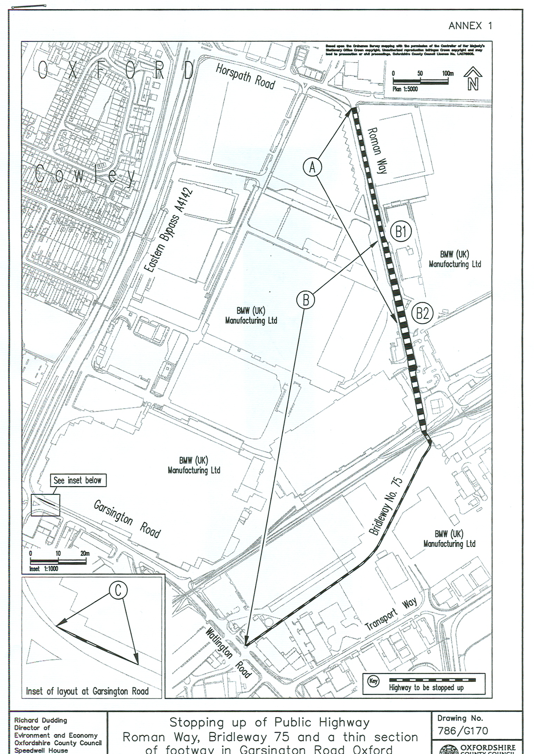
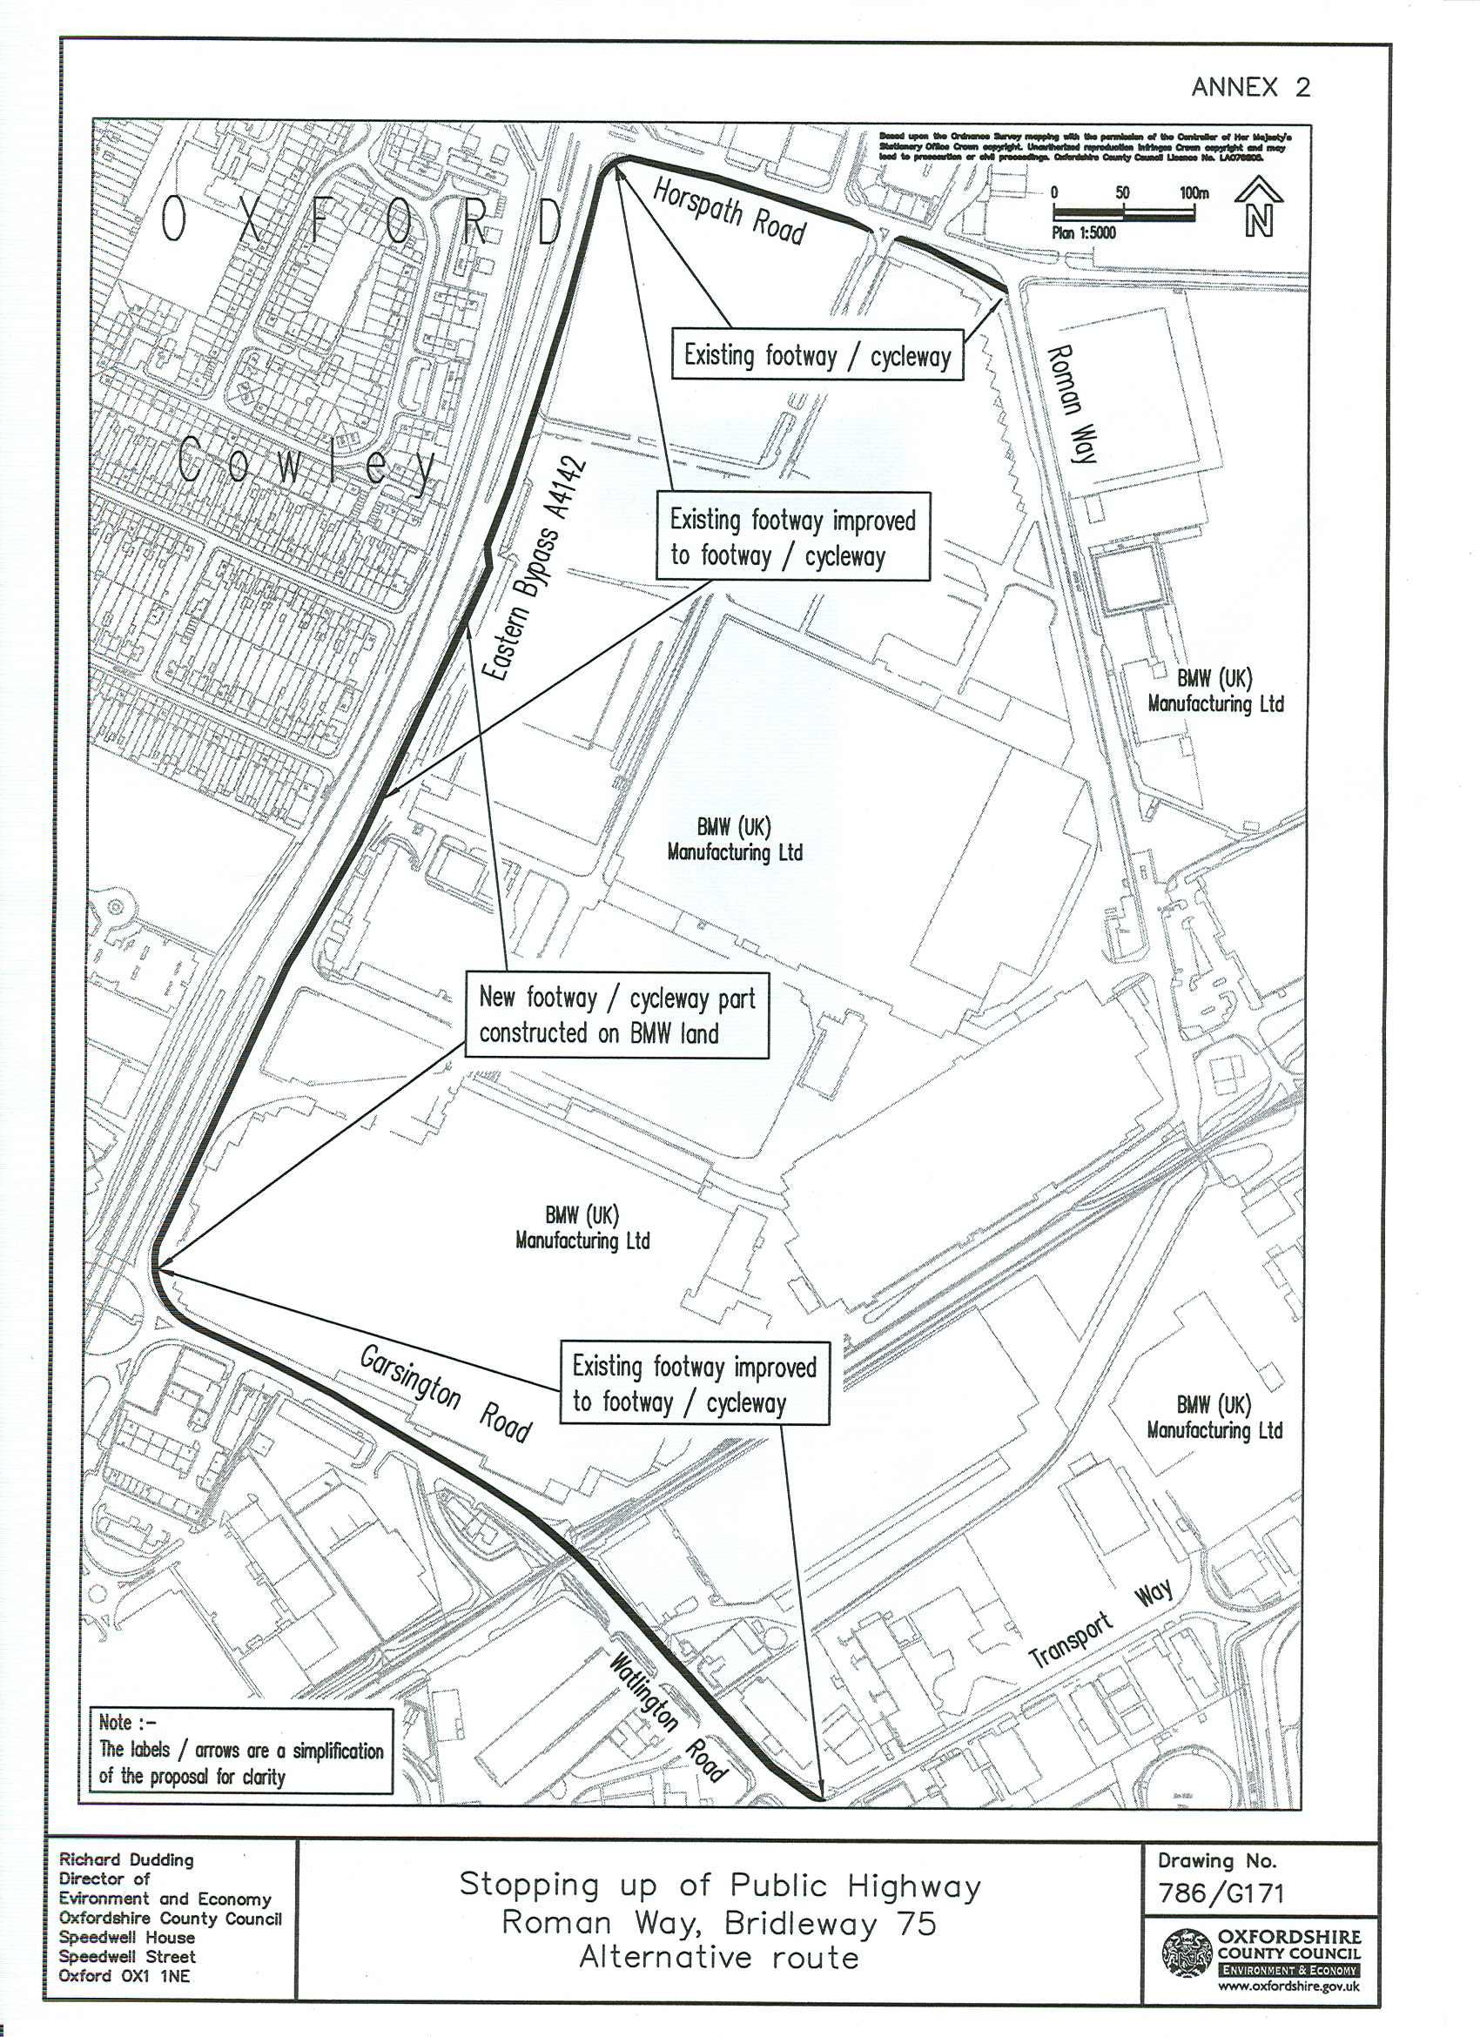
ANNEX 3
Summary of the comments received during the Consultation

Respondent | Support proposal | Comments | Officer Comments
Oxford City Council | NYK | The City Council has reserved its response until the formal notice under section 116 is received. | Await response if formal notice given.
Horspath Parish Council | N | - Bridleway 75 provides a convenient cycle route to many facilities in this part of Oxford.  - The revised route is longer.  - The existing route is more environmentally friendly to cyclists.  - Lack of clarity over traffic segregation from the map provided.  - Unfortunate that such an historic route may be lost. | The alternative will provide a similar link.  See CTC response below.  This is accepted.  Part of the alternative is segregated and set well back from the bypass. Community safety problems have been identified on the existing route.  Detailed plans of the alternative scheme were put on public deposit.  About 60% of the existing route is no longer on the ancient line due to past changes. There appear to be no historic features on the remainder.
Prosidion Ltd.  Windrush Court, Watlington Road |  | Will consult staff and respond before deadline. | To date no response has been received.
The Ramblers’ Association | N | Wholly unacceptable for several reasons that will be communicated to OCC. | No comments received to date.
Oxford Area Bridleways Association  OABA cont.  OABA cont.  OABA cont. | N | 1. Existing bridleway forms part of extended bridleway network for City equestrians to access the fields and routes to Shotover Country Park. See route card Oxon. 1029.  2. City equestrians are pressing for more and better/safer access in and around Oxford as part of an overall plan of improvement for joining up the network. This is in line with DEFRA/British Horse Industry Strategy aims, OCC’s Rights of Way Improvement Plan and the City Council’s Local Plan.  3. The bridleway is in regular use, including by pedestrians and cyclists.  4. The alternative has no provision for equestrians which is counter to the provisions in 2 above. Equestrians are a significant and growing body.  5. There appears to have been no consultation with the British Horse Society and others users may not be fully aware.  6. The proposed route is at least 25% longer.  7. The proposed route runs alongside the Eastern Bypass, a very busy dual carriageway. The noise and pollution will make the route oppressive and unhealthy.  8. It is untrue the existing bridleway is isolated from other routes. It leads to Roman Way then to Horspath Road almost across from which runs restricted byway 14. This leads to Brasenose Wood and Shotover with its bridleway network.  On the Watlington Road side 0.5 km away is bridleway 9 that links to bridleway 12 and 6 with off road routes to Toot Baldon, Garsington and Littlemore.  9. It is unclear exactly who has been consulted.  10. BMW’s submission and the consultation were partial to those who wished to stop up the route.  11. Overall the process does not appear to have been widely fair, democratic or transparent.  12. The bridleway is centuries old, part of our heritage and used by local people and pedestrians and riders from Horspath at one end and people from Iffley at the other. As more people are aware of it, it is being used as a regular equestrian route.  13. Ideally it should be upgraded, cleared of rubbish and with the correct width at the gates.  14. BMW’s eastern route might be acceptable provided the surface is suitable for equestrians and a link is made along Horspath Road to restricted byway 14.  15. Not convinced security is BMW’s motive.  16. A petition objecting to the closure is attached. | Prior to the consultation no evidence of equestrian use was found. The route card appears to have been recently produced and a large part of the suggested route follows verges next to busy roads with no dedicated equestrian provision.  It is accepted that the policies identified do encourage wider public use of footpaths and bridleways. However Council Policies also recognise the economic needs of BMW and others.  A balance will need to be found.  The alternative route will provide a replacement for this public use, also see answer to 1 above.  Equestrian use was not identified and consequently not considered for alternative provision.  An informal consultation exercise was undertaken including BHS.  This is accepted.  About 52% of the alternative route fronts the bypass and of this, about 70% is set back from the line of the main bypass carriageway.  To reach the bridleway it is necessary to use verges/pavements adjacent to busy roads. In turn these roads do connect with other rights of way.  An informal consultation exercise was carried out.  Clearly BMW’s submission is in favour of the closure but there is no reason to believe the survey was not completely impartial.  The informal process was completely democratic and transparent as the formal will be if approval is given.  As mentioned above only part is now on the ancient line. There is no evidence of past equestrian use.  If the route remains considerations like this will be dependant on funding.  BMW do not consider this route viable.  No comment.  Available for inspection in the members’ resource centre.
C. Cllr for Chalgrove Division | N | 1. This is a long established, well used and very useful public right of way. It is used by, adult pedestrians and cyclists going to and from work and by young people on their route to and from school. It is also used to access the recreational facilities at Horspath Road.  2. The alternative represents a long detour and is much less safe in terms of highway traffic. | The replacement will provide an alternative route for pedestrians and cyclists.  The alternative is longer but provides segregated sections for pedestrians and cyclists over part and CTC are in favour. There is evidence of public safety problems associated with the use of the existing route.
District Cllr. for Wheatley and Horspath | N | 1. Use the route to access Greater Leys area e.g. Oxford College Campus and the Kassam Stadium and film studio.  2. The route is ideal for young people in Horspath since it is well away from the busy ring road and the potentially hazardous roundabout near the retail park. It gives parents peace of mind to allow youngsters the freedom to go to football matches etc.  3. The consultation paper gives no operational justification for the closure, the map is meaningless and the improvements are impossible to assess as no details are provided. | The alternative will also provide access to these premises.  Part of the alternative route is segregated and set well back from the busy road. There are community safety issues particularly associated with the high fenced section of the existing.  Detailed information was on deposit at four public buildings. The locations were made known to all.
Resident of Stanton St. John | N | 1. Bridleway routinely used for a long ride linking Forest Hill, Shotover (Brasenose Wood), Horspath, Wheatley and back to Forest Hill. If so, the loss would be a significant break in the County network.  2. It is even more important with the closure of the access to Shotover from the A40. | The alternative will provide a cycle link in replacement but not for horse riders.  The alternative will maintain a connection in the network but not for horse riders.
Resident of Headington Quarry  Resident of Headington Quarry cont. | N | 1. BMW’s grounds for the application are operational reasons which alone does not substantiate a case for either of the two criteria under s116 of the Highways Act 1980.  2. The applicant must prove the bridleway is unnecessary. This cannot be so; historic maps show this right of way as the old roman road from Silchester to Dorchester, used for centuries.  3. Resident uses it regularly and has seen others doing the same. No doubt used daily and is the only off road route between Blackbird Leys and the Shotover Country Park area.  4. The alternative fails to meet the nearer or more commodious criteria. It simply replicates an existing path and cycleway adjacent to the major road meaning users will be next to roaring traffic noise and fumes.  5. Oxford City Council have a policy of fostering more walking and cycling as part of its overall transport and traffic reduction strategy; supporting government initiatives relating to exercise and good health. A key part of this must be the maintenance of the city footpath network and the encouragement of residents to use them. To remove this bridleway would be a betrayal of this policy.  6. BMW should consider a route around the Horspath side of their land which would provide a quiet and away from major road route. | Operational reasons are criteria the Magistrates cannot take into account when judging a case under this legislation.  It is a matter for the magistrates to weigh this issue on the evidence presented and representations made at the hearing.  The alternative will provide a replacement for pedestrian and cyclist use only.  The existing route has unsatisfactory elements like, no public lighting, adjacent high fences and conflict with business traffic that are clearly issues to consider.  The City Council will have the opportunity to consider these issues if approval for the next stage is given.  BMW do not consider this route viable.
Headington Road Runners | N | See 1 to 6 above. | This letter mirrors closely the one from the Headington Quarry resident above. The officer’s comments are therefore the same.
CPRE  CPRE cont. | N | 1. This route is an important direct link for pedestrians, cyclists and horse riders.  2. The alternative is longer, dangerous in terms of width and exposure to traffic and noisy, polluted and generally unpleasant.  3. Will generate more car traffic.  4. Will be prepared to consider a route to the east. | The alternative will provide the same link for pedestrians and cyclists. There was no evidence of use by horse riders.  Part of the new route is set well back from the bypass and segregated where the issues of danger, pollution etc. may not be as significant as suggested. A section will be adjacent to the slip road where segregation is not possible.  No evidence to determine whether this would result.  BMW do not consider this route viable.
Open Space Society | N | Similar comment to 2 above by CPRE. | The same.
Resident of Garsington | N | 1. Existing route still in use for access to BMW bus garage and schools.  2. Provide an alternative to using the eastern bypass. | Alternative will provide a similar link. BMW have a commitment to provide a new access to the Plant from the south.  The alternative proposed by BMW appears to be the only viable option.
Countryside Services | N | 1. The existing route cannot be said to be unnecessary as the alternative does not provide for equestrians.  2. Concern over the reasonable suitability of the alternative for pedestrians and cyclists. | Matter for the Magistrates to decide if it goes that far.  Again a matter for the Magistrates.
CTC the National Cyclists Organisation  CTC the National Cyclists Organisation cont. | Y | 1. The proposal as it stands offers an enhancement to provision for utility cycling in this area of Oxford.  2. Provide a direct link from Blackbird Leys towards the northwest avoiding the Watlington Road/Eastern Bypass junction. | They appear to see the change as an advantage to cyclists.  The alternative may encourage cyclists to do this.

STOPPING UP OF HIGHWAYS IN THE CITY OF OXFORD AT THE
BMW (UK) MANUFACTURING PLANT, COWLEY

SCHEDULE TO BE READ IN CONJUNCTION WITH STOPPING UP PLAN No 786/G170

Highways to be Stopped up for the purpose of all traffic |  |  | Particulars of Replacement Highway
IdentificationLetter | Highway Status | Description | Particulars of Replacement Highway
A | Unclassified Vehicular Highway | Roman Way for its full width from a point approximately 16.5m from the Horspath Road stop line, southwards for a distance of approximately 402m where it abuts the limit of the stopping up order made on 27 February 1979. | None
B | Bridleway 75 | For its entire length and width from a point in Roman Way approximately 255m south of the junction with Horspath Road south and southwest to its junction with Watlington Road (noted on the definitive statement as approximately 930m in length). Section B1 to B2 runs concurrently with the vehicular highway in A above. | Existing footway and cycle track on the south side of Horspath Road, westwards from Roman Way and southwards along the east side of the Eastern Bypass (A4142) including the creation of a new footway and cycle track southwards to Garsington Road and then eastwards along the north side of Garsington Road and the Watlington road, past the junction with bridleway 75, to the junction with Transport Way.
C | Footway | A thin tapering section of the northern footway to Garsington Road approximately 35 m in length (see inset on stopping up plan). | None

