ANNEX 1

SEEDA consultation on Economic Strategy - Proposed division of Oxfordshire between Inner and Outer South East

4 January 2005

Prepared by Margaret Melling, Demographic and Social Statistics Adviser, Oxfordshire County Council

Introduction
The SEEDA consultation paper “the Review of Regional economic Strategy for South East England 2006-2016” proposes a division of the South East region into Growth Areas, Inner South East, Outer South East and Coastal South East.
In this new categorisation Oxfordshire is split between Inner and Outer South East with:
Inner South East including: Oxford, South Oxfordshire and a small area in the east of the Vale of White Horse district.
Outer South East including: Cherwell, West Oxfordshire and the majority of the Vale of White Horse district.

There are two main evidence-based arguments against splitting the county in this way:
- Social and economic data shows strong similarities between Oxfordshire’s four rural districts.
- Oxfordshire functions as an economic unit (city region).
  - The commuting catchment of Oxford extends throughout the county.
  - The influence of the city of Oxford on the prosperity of Oxfordshire’s rural towns and villages.
  - Drawing the Inner/Outer northern boundary tight to the city local authority boundary excludes areas such as Kidlington, Oxford Airport and the businesses in that area.

Social and economic data
2.1 Rural population
South Oxfordshire was the county’s second most rural district according to the 2001 census.
On this measure South Oxfordshire would be included in “Outer South East” like most of the Vale and the whole of West and Cherwell.
Table 1: 2001 Population density sorted in descending order (most sparse at the top)
 | 2001 population per hectare
West Oxfordshire | 1.34
South Oxfordshire | 1.89
Vale of White Horse | 2.00
Cherwell | 2.24
Oxford | 29.44
Oxfordshire | 2.32
SOUTH EAST | 4.20
Source: ONS Census 2001 Crown Copyright reserved (extract from table KS01)

2.2 Age distribution
South, Vale and West show an almost identical age distribution.

Table 2: 2001 % of people by selected age bands
Age range | Cherwell | City of Oxford | South Oxfordshire | Vale of White Horse | West Oxfordshire
0-19 | 25.5% | 23.1% | 24.7% | 25.5% | 24.7%
20-35 | 23.0% | 34.9% | 20.0% | 19.4% | 19.6%
36-55 | 29.3% | 22.4% | 30.0% | 29.9% | 29.8%
55+ | 23.3% | 20.5% | 26.7% | 26.5% | 27.2%
Source: ONS Census 2001 Crown Copyright reserved
  - Pockets of Deprivation
According to the Indices of Deprivation published by ODPM in 2004, there are 13 areas of Oxfordshire (out of a total of 404 super output areas) which are within the top 20% most deprived nationally. Of these most deprived super output areas (SOAs), 10 are in Oxford and 3 are in Banbury.
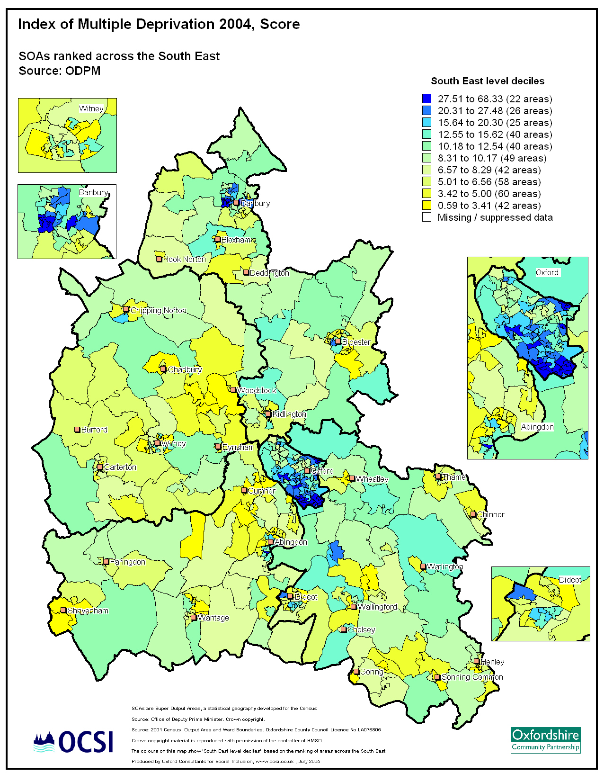
The following map shows the IMD 2004 result with rankings based on IMD results for super output areas in the South East region. This shows pockets of deprivation in Oxford city and Banbury and broadly similar results elsewhere (with the exception of Berinsfield in South Oxfordshire with its high proportion of social rented housing and lower than average educational attainment).

The following map shows the Crime and Disorder sub domain of the IMD again with rankings based on the IMD results across the South East. This map shows the distinct difference between the western and eastern sections of the county on this measure.
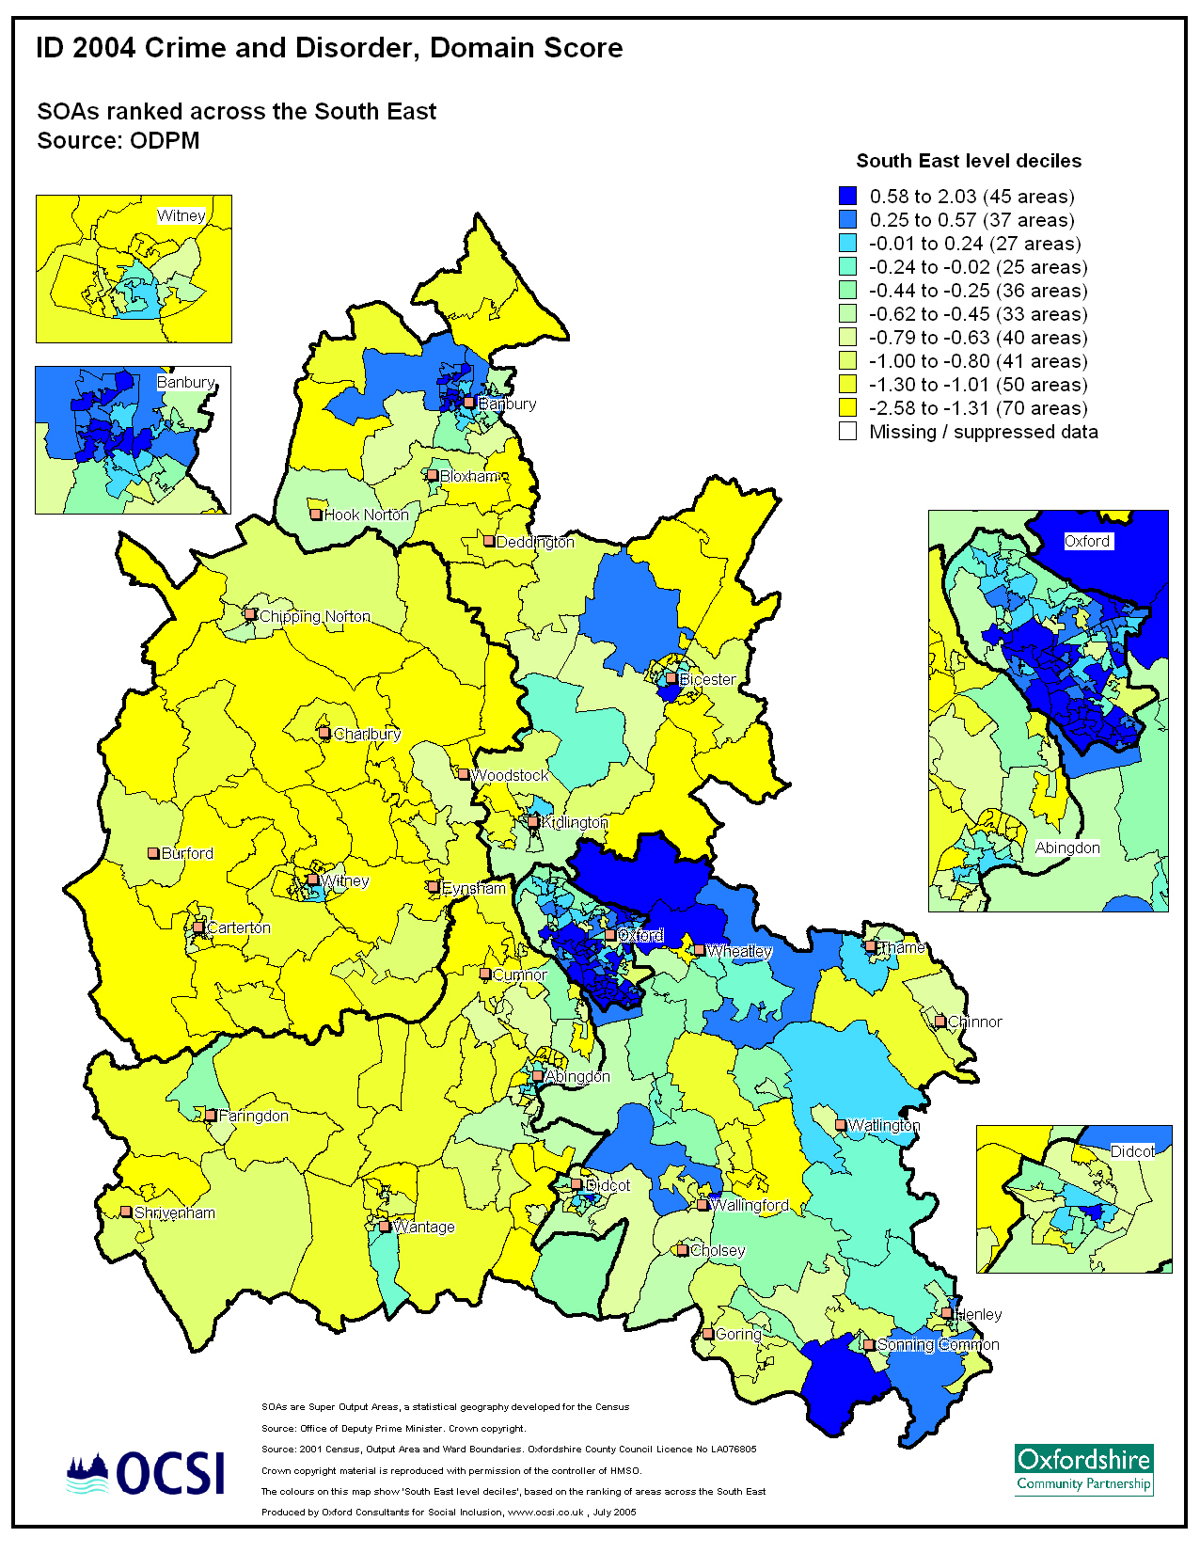

2.4 Economic and skills indicators
Skills deprivation
Whilst Oxfordshire, in common with other areas of the South East, enjoys relatively high employment and low overall deprivation, the IMD and other data highlights a particular issue with education, skills and training in the county.
The following map shows the Children/ Young people Education, Skills and training sub domain score with ranking based on the IMD results across the South East region (see appendix for the indicators included in the sub domain). All districts include some areas which are deprived (blue).
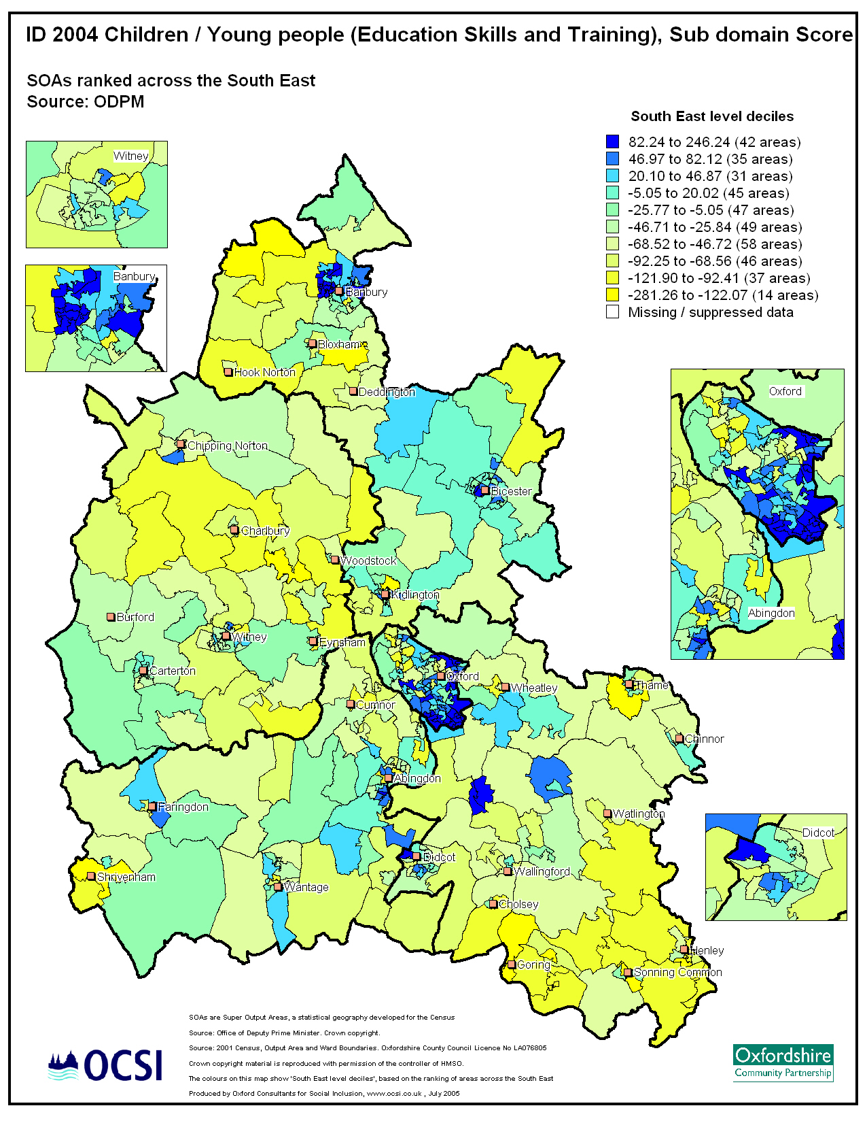

Oxfordshire remains close to the national average on the % of pupils gaining 5 or more GCSE grades at A*-C. Cherwell and Oxford are the districts with the lowest average attainment.

Table 3: % of pupils gaining 5 or more GCSEs at grades A*-C
 | 2000 | 2001 | 2002 | 2003 | 2004 | 2005 | Change 2004-5
England (maintained schools) | 46.9 | 47.8 | 49.1 | 50.8 | 51.3 | 54.2 | 2.9
Oxfordshire LEA | 50.9 | 49.8 | 51.7 | 51.5 | 50.6 | 54.3 | 3.7
Cherwell | 45.2 | 42.4 | 45.5 | 45.6 | 43.6 | 49.5 | 5.9
Oxford City | 43.3 | 44.5 | 43 | 43.6 | 40.4 | 40.9 | 0.5
South Oxfordshire | 58.1 | 58.5 | 61 | 59.4 | 58.8 | 60.6 | 1.8
Vale of White Horse | 48.3 | 47.6 | 48.2 | 51.1 | 52.8 | 56.5 | 3.7
West Oxfordshire | 57.3 | 57.8 | 61.5 | 60.2 | 60.6 | 63.4 | 2.8

Employment and income-related benefits
Earnings per head data shows South Oxfordshire with the highest level, but little difference between South and the Vale of WH districts.

Table 3: Earnings per head
 | 2000/01 | 2001/02 | % change
Cherwell | 15,363 | 18,846 | 22.7%
Oxford | 19,494 | 19,857 | 1.9%
South Oxfordshire | 21,395 | 23,257 | 8.7%
Vale of White Horse | 20,498 | 22,798 | 11.2%
West Oxfordshire | 15,701 | 20,510 | 30.6%
Oxfordshire | 18,671 | 21,217 | 13.6%
South East | 17,405 | 20,336 | 16.8%
ENGLAND | 13,081 | 15,585 | 19.1%
Source: Inland Revenue

Take up of income and job seeker related benefits shows very little difference between the South, Vale and West Oxfordshire districts.

Table 4: % working age people claiming income support and jobseeker allowance (2003)
England | 9.7%
South East | 6.4%
Oxfordshire | 4.9%
Cherwell | 4.9%
Oxford | 7.0%
South Oxfordshire | 3.9%
Vale of White Horse | 4.0%
West Oxfordshire | 4.2%
Source: DWP, ONS

APPENDIX – Indicators in IMD Education Skills & Training Deprivation Domain
This domain is designed to capture the extent of deprivation in education, skills and training in a local area. The indicators fall into two sub-domains: one relating to lack of attainment among children and young people and one relating to lack of qualifications in terms of skills. These two sub-domains are designed to reflect the ‘flow’ and ‘stock’ of educational disadvantage within an area respectively. That is, the children/young people sub-domain measures the deprivation in the attaining of qualifications, while the skills sub-domain measures the deprivation in the resident working age adult population.

THE INDICATORS
Sub-Domain: Children/Young People
1. Average points score of pupils at Key Stage 2 (end of primary) (2002, Source: Pupil Level Annual School Census (PLASC) and the National Pupil Database (NPD) from the DfES).
2. Average points score of pupils at Key Stage 3 (2002, Source: Pupil Level Annual School Census (PLASC) and the National Pupil Database (NPD) from the DfES).
3. Average points score of pupils at Key Stage 4 (GCSE/GNVQ – best of eight results) (2002, Source: Pupil Level Annual School Census (PLASC) and the National Pupil Database (NPD) from the DfES).
4. Proportion of young people not staying on in school or non-advanced further education above 16 (Child Benefit 2001, Source: DWP).
5. Secondary school absence rate (Average of 2001 and 2002, Source: DfES school level survey of authorised and unauthorised absences, allocated to the local area via the PLASC data, DfES).
6. Proportion of those aged under 21 not entering Higher Education (1999-2002, Source: UCAS).
Sub-Domain: Skills
1. Proportions of working age adults (aged 25-54) in the area with no or low qualifications (2001, Source: 2001 Census).

