ANNEX 1

ANNEX 2
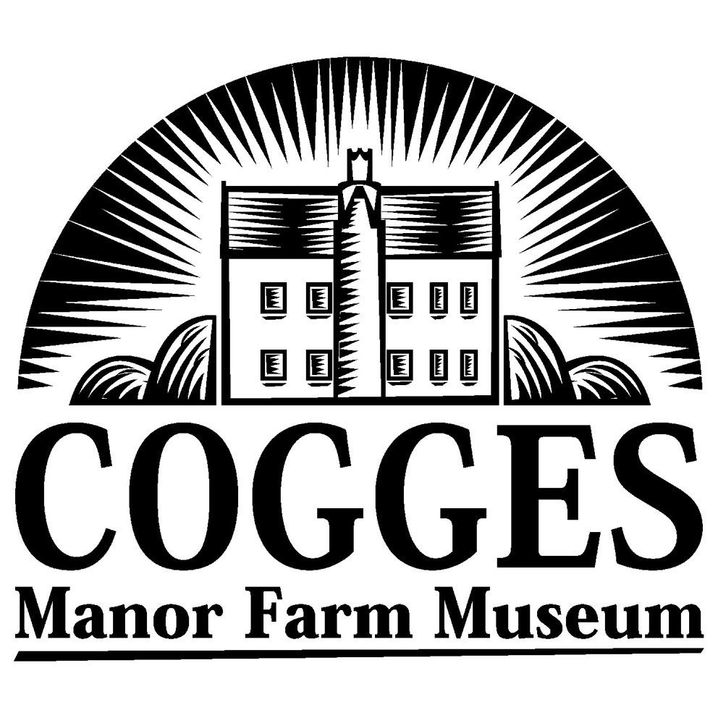

Development Plan

Introduction

Cogges Manor Farm was purchased by Oxfordshire County Council (OCC) in 1974 to become a museum of farming and the countryside for the County. The site consists of the historic Manor House, farmyard, original Cotswold farm buildings and 18 acres of surrounding meadow and woodland.

The Museum first opened its doors to the public in 1978 and has been operating as a seasonal local attraction since. It was managed by OCC until 1998, when the County Council faced budget cuts and had to hand over management of the Museum to West Oxfordshire District Council (WODC). Sadly in 2004 WODC faced similar budget cuts and the management of the Museum was transferred back to OCC on 1st March 2005. The Museum is open on six days a week from Easter to October each year.

The Museum aims to present a picture of rural life in Oxfordshire in the late 1800s. The farm is stocked with traditional breeds of animals including Cotswold and Oxford Down sheep, Shorthorn cows and Gloucester Old Spot pigs. There are displays of farm implements, wagons and machinery as well as an audio tour, which uses characters from the Manor’s history and extracts from literature to bring the farmyard to life.

The Manor House has been restored and includes two working kitchens, a Victorian bedroom, a rare example of a 17th century decorative scheme and a nursery. There is also a separate Dairy.

Staff dressed in simplified late Victorian costumes are seen occupied in typical daily tasks around the farmyard and in the Manor House, such as milking the cows by hand, making butter, cooking and doing the laundry. They respond to visitors’ questions and offer explanations of their actions.

The formal education programme is targeted at Key Stages 1 and 2 and covers a variety of topics based on Victorian life. Over 4,000 school children use the formal education service each season.

The site also includes a walled kitchen garden, an orchard picnic area and a riverside walk. The existing visitor centre houses the main reception, the gift shop and the Old Milking Parlour Tea Room.

A regular programme of events includes theme weekends such as Spring on the Farm, Rural Traditions, Textiles, Threshing & Harvest, Tudors & Stuarts and Advent. The Museum also offers daily activities during school holidays and a series of summer evening performances.

A Brief History of Cogges Manor Farm

Cogges Manor Farm Museum is an important heritage site and a Scheduled Ancient Monument. The Manor House dates from the thirteenth century and is Listed Grade II*. The unique collection of original Cotswold farm buildings are also all Listed Grade II.

The history of the site at Cogges can be traced back over a thousand years using evidence from the archaeological remains, records and buildings left behind by the people who have lived and worked there over the centuries.

The earliest known owner of Cogges was Wadard. He was recorded as Lord of the Manor of Cogges in the Domesday Book of 1086. Wadard was shown as a Norman knight riding a horse on the Bayeaux Tapestry celebrating the victory of William the Conqueror at the Battle of Hastings in 1066.

The Manor next became the property of the Arsic family who probably built the first Manor House before 1100. It originally stood near the River Windrush inside a defensive moat, which can still be seen today. Although there is now no sign of the house above ground, it was still visible in the 17th century when it was described as ‘Cogges Castle’.

The Arsic family were still Lords of the Manor at Cogges in 1213 when Robert Arsic established a settlement for Freemen called Newland. This is now part of Witney, but in the early 13th century it was planned as a separate community to rival the recently created market town. The Bishops of Winchester developed Witney around the market place and built a palace next to Church Green, the original foundations of which can be seen today.

The long-term effect of the 13th century development was that the village of Cogges declined instead of growing larger like its neighbour Witney. Today the remains of the medieval village are apparent in the field next to the orchard. There are mysterious bumps and hollows in the ground over the foundations of the village buildings and large clumps of nettles grow where the ground was disturbed.

By 1245 Cogges had a new owner. Walter de Grey, Chancellor, Regent of England and Archbishop of York, gave the land to his nephew who was also called Walter de Grey. It was at this time that a new Manor House was built on higher and drier ground away from the river. The foundations of this house were uncovered during archaeological excavations in 1991 and 1992, adjacent to the house we see today.

The descendants of the de Grey family supported the Yorkist cause during the War of the Roses. After their defeat, the new King Henry VII seized the lands of many of those who had fought against him. This included Cogges and for many years thereafter followed a succession of absentee landlords.

It was the middle of the 16th century before Cogges found another local owner. Sir Thomas Pope, the founder of Trinity College in Oxford, was granted the land by Henry VIII. The roof structure and the upper rooms above the present kitchens may have been built at this time. However, the tall kitchen windows which overlook the garden and the doorway into the dairy yard seem to be older than the rest of this part of the house.

In 1667 the estate was sold for £8000 to Francis Blake, a woollen draper from London, who was involved in the Witney blanket trade. He remodelled the taller east wing of the house. Originally this façade was rendered red with fake stonework around the windows and corners to imitate a fashionable Tudor brick house.

The Blake family sold the Manor including ‘The Manor House and the two great barns and the stables and outhouses, yards, orchard and appurtenances’ to Lord Harcourt in 1725. During the next fifty years it was let to a variety of tenants, including two schools. Mr Moreland’s boarding school advertised in 1759 that ‘young gentlemen are instructed in Merchants’ Accounts and the nature of Foreign Exchanges, French, Drawing, Dancing and other branches of polite education suited to the Pupil’s Genius and Capacity, on moderate terms’. However, by 1766 the school had closed and its furniture and equipment had been sold.

After the school closed the house lay empty and began to deteriorate. It is recorded that the Harcourts were planning to construct a new farm ‘with the material of the Old Manor House, which is at present made no use of’. Fortunately, the house was re-let to the Hollis family instead. They lived and farmed at Cogges for almost 100 years. Among the Harcourt Estate Papers are numerous tradesmen’s accounts for materials used to repair the house and farm buildings during this period.

In 1877 Joseph Mawle, a local farmer from Worminghall, took over the tenancy. He moved to Cogges with his wife Elizabeth, his sons Joseph Bury aged 11, John Francis (Frank) 10, Edward Ernest 7, Harry 5 and daughters Elsie 3 and baby Eliza. In 1879 another daughter Margaret was born at Cogges, followed in 1882 by the youngest son Ralph.

This was a time of agricultural depression when many small farmers were unable to make a living from their land. Joseph Mawle improved the fields by introducing clay drainage pipes. He grew crops and kept cattle as well as sheep and by 1900 the 500 acre farm was prosperous.

It is at this time that the clock has been stopped at Cogges. Visitors to the Museum see the house, farm and garden as they would have been in the late 1800s.

Aims of the Museum

Mission Statement
Cogges Manor Farm Museum aims to enhance people’s understanding and inspire their interest in the cultural, social and rural heritage of Cogges and the surrounding area of Oxfordshire through looking after the Museum’s collections, lively interpretation and inclusive events programmes.

Key Aims
- To inspire and challenge people to explore the history of the site, the associated collections and the rural lifestyles of the past.
- To ensure that the management of the site is sympathetic to the environment and traditions of rural Oxfordshire and maintains the integrity of the historic environment.
- To maximise the Museum’s potential as a learning resource for all sections of the community.
- To provide high quality, entertaining and socially inclusive displays, temporary exhibitions and events.
- To work in partnership with Oxfordshire County Museum Service to achieve best practice in the care and management of the Museum’s collections.
- To foster community identity by understanding the diverse needs and aspirations of the Museum’s audiences and working in partnership with those groups to help them determine a positive relationship with the Museum.

Development Objectives

Project A – A Visitor Centre

The main elements of this project are:
- To build a new reception centre to house welcoming visitor services, including admissions, a souvenir and gift shop, a café, toilets and baby-changing facilities. These would be designed to be fully accessible by wheelchair users and those with physical impairments and would meet all the appropriate Health and Safety requirements.
- This new building would allow the relocation of modern facilities used by visitors away from the historic centre of the site and help preserve the unique atmosphere and integrity of the Museum. The new centre itself would be located 200m from the historic farm complex, within the existing Museum car park, allowing visitors to take a step back in time as they exit the modern surroundings of reception and cross the field to the farm.
- The new centre would also include environmentally stable gallery space for the display of the Nina Carroll collection of paintings of Cogges and temporary exhibitions of other relevant objects from the County collections. The building’s contemporary style would provide a suitable atmosphere for widening the Museum’s role in reflecting the many important issues currently affecting farming and the rural economy and would work in harmony with the presentation of the rural past as depicted within the neighbouring historic site. This gallery space would be made available to local community groups, artists and craftspeople for their own exhibitions.
- The development of the new centre would allow the historic milking parlour to be used as a dedicated education space. This would include an introductory video for visitors to the Museum as well as space and facilities for learning by a wide range of groups.
- The Museum’s ability to generate income would be increased through the provision of better tea room and shop services open both to Museum visitors and to the local community, an exhibition space that can be used throughout the year for exhibitions and events or for hire by local groups, and an education space available to host seminars, conferences and teaching courses.

Architect’s designs and planning permission to build the proposed new Visitor Centre have already been acquired.

Proposal B – Capital Improvements to Existing Buildings

- The refurbishment of the existing toilets, which are currently situated in the old granary building. These would be improved for use by both visitors and staff. Particular attention would be paid to improving the toilet facilities for visitors with disabilities, for large groups of school children and for visitors with baby changing needs. However, despite any improvements made to the existing toilets, they are still fundamentally too few in number to be adequate for large numbers of visitors and in particular for school groups and coach parties. They are also situated at a considerable distance from the Tea Room and visitors have to cross an often muddy farmyard full of inherent health hazards between washing their hands and eating or drinking.
- Provision of new toilets. To increase the number of toilets provided on the site, the farm shed in the front yard would be replaced with a permanent building to house both toilet facilities adjacent to the Tea Room and adequate and appropriate storage space for catering supplies. This would offer more convenient and hygienic facilities for visitors, as well as making out-of-hours use of the Tea Room possible without the need for the whole site to be open. Neither of these improvements would work alone and therefore funding for both would be required if any effective improvement was to be made.
- Provision of a Barley Barn exhibition. The smaller of the two barns at the Museum would be used to house a new, permanent, interactive display on the history of the Oxfordshire countryside that would appeal to visitors of all ages and increase the Museum’s potential to attract repeat visits. A small area within the Barn would be retained for a programme of temporary exhibitions relating to the main theme, and tackling some of the contemporary issues relating to the countryside such as genetic farming, the right to roam and hunting. In order to provide a suitable space in the Barn, new flooring and heating would be required. A mezzanine floor would be added to increase display and education work space and the roof torching, doors and ventilation holes would all need to be effectively sealed. All of this work would require Listed Building Consent with approval from English Heritage.
- Refurbishment of the Manor House displays. The displays in the rooms of the Manor House were re-opened in 1996 and have not been refurbished since. Consequently they are tired, outdated and in a bad state of repair. In order to improve the interest and appeal of Cogges as both an historic house and a learning resource, the themes and topics covered within the House would be reviewed and new, accessible and appropriate displays designed and installed.
- The improvement of site signage. Signage across the whole of the Museum site is old, out-of-date and in an extremely poor state of repair. Directional signage would be reviewed and improved in consultation with users, and external information signage would be refurbished to develop the interpretation of the whole site.
- The development of catering and retail facilities. The Museum gift shop was refitted at the beginning of the 2005 season and improvements have been made to retail displays. To develop the Museum’s income generating potential to its full a new reception point is also needed from where better promotion of the Museum services such as the audio tour and programme of events would be possible. New furniture has also been recently purchased for the Tea Room, increasing the total seating capacity. Unfortunately the food preparation space and equipment is still extremely limited, meaning that little benefit can currently be taken from the increased capacity. Refurbishing the food preparation area and upgrading storage and equipment would allow an improved range of higher quality food to be sold and served.

Scheduled Ancient Monument and Listed Buildings Consent

The status of the entire 20 acre site at Cogges as a Scheduled Ancient Monument imposes serious limitations on capital development at the Museum. No new building is permitted within the boundaries of the Monument, which is why Proposal A above is preferable if funding for a new Visitor Centre on the site of the main car park could be secured. Should Proposal B be pursued, nearly all of the capital work outlined would require the appropriate planning consent and a delay of up to 12 months should therefore be anticipated.

Visitor Profile

Visitor Figures

 | 2001 (a) | 2002 | 2003 | 2004 (b)
Total Number of Visitors | 14,754 | 33,906 | 27,533 | 24,988
Number of School Children in Pre-booked Groups | 3,013 | 5,555 | 5,381 | 4,786

  - In 2001 the Museum was seriously affected by the outbreak of Foot and Mouth Disease and fell within a restricted area. For that reason it was unable to open until the end of June, but remained open throughout November and closed after the Advent weekend at the beginning of December.
  - In 2004, the managing authority was West Oxfordshire District Council. In a bid to make budget cuts within Cultural Services, the Museum’s opening hours were reduced so it closed at the end of October (re-opening again just for the Advent weekend) and throughout October it closed daily at 4pm rather than at 5.30pm.

Visitor Breakdown

The total visitor figures can be broken down into the following groups:

Adults make up approximately 19% of the total figure.
Children make up approximately 13% of the total figure.
Concessions make up approximately 12% of the total figure.
Family groups make up approximately 9% of the total figure.
School children make up approximately 19% of the total figure.
Season ticket holders make up approximately 8% of the total figure.
Free under 3s make up approximately 8% of the total figure.
Free teachers (accompanying booked school groups) make up approximately 3% of the total figure.
Tea Room only visitors make up approximately 6 % of the total figure.
The other 3% of the total figure is made up of free demonstrators and visitors to the site.

Visitor surveys show that most visitors travel to Cogges by car or by coach. Most come from within a 50 mile radius of the Museum and most find out about Cogges by word of mouth or by picking up a leaflet. 75% of visitors have been more than once.

Financial Implications

Capital

The capital cost of Proposal A would be £1 million. This would fund the new Visitor Centre building on the main car park site, the internal fitting out of the new space and the adaptation of the old milking parlour (currently the reception, gift shop and tea room) to create a dedicated education space.

The capital cost of Proposal B would be £500,000. This would be broken down as below:

1. Refurbishment of existing toilets £25,000
2. Provision of new toilets £100,000
3. Barley Barn exhibition £250,000
4. Refurbishment of Manor House displays £ 75,000
5. Improvement of site signage £20,000
6. Development of catering & retail facilities £30,000

Revenue

A revenue budget of £132,500 is currently provided by Oxfordshire County Council as owners and managers of Cogges Manor Farm Museum. This budget covers staffing, premises related expenses, supplies and services. To support either of the proposed capital investment programmes outlined above, this revenue stream would need to be secured over a minimum period of three years and increased to include the following priorities.

- Marketing – in order to effectively market the new developments and increase visitor figures, an annual marketing budget of £25,000 would be required.
- Learning and access – in order to develop formal and informal education programmes to make use of the resources and facilities at Cogges Manor Farm Museum, a full-time post would need to be funded at £30,000 per annum.

Income Generation

The Museum currently has an income target of £215,000 per annum to be made through admissions, retail, catering and donations. This is currently not a realistic target and is unlikely to be achieved in the current year.

However, with the much needed additional investment in catering and retail facilities as well as in marketing and staffing, the potential to generate income could be effectively developed over a period of three years.

Conclusion

Cogges Manor Farm Museum has been suffering from a lack of funding for the last 5 years. It has stood still while the competition for visitors has raced ahead. This problem was exacerbated when the Museum fell victim to the Foot and Mouth crisis in 2001 and was unable to invest in marketing and improvements to pull itself out of the ensuing slump. It is further complicated by the ongoing uncertainty of local authority funding, which is such that discussions about closing the Museum have happened in each of the last three years. The public nature of these considerations has given negative messages to the public and potential visitors, as well as making long-term planning for the future impossible.

The heritage assets at Cogges are unique and hold enormous potential for broadening the appeal of the Museum. With appropriate investment in visitor facilities and services, Cogges has all the ingredients necessary to become a primary destination for tourists to the Oxfordshire Cotswolds as well as strengthening and building on its already key role as a valuable education resource and a local, community facility.

For Cogges Manor Farm Museum to survive, it is essential that funding is found to make the capital improvements outlined in this plan and that a revenue funding is guaranteed for a period of at least 3 years. Given those investments the Museum would have the necessary resources to develop income generation and eventually to become a self-sustaining, successful business independent of the political fluctuations of local government management.

