APPENDIX 1

Our Vision for Oxfordshire
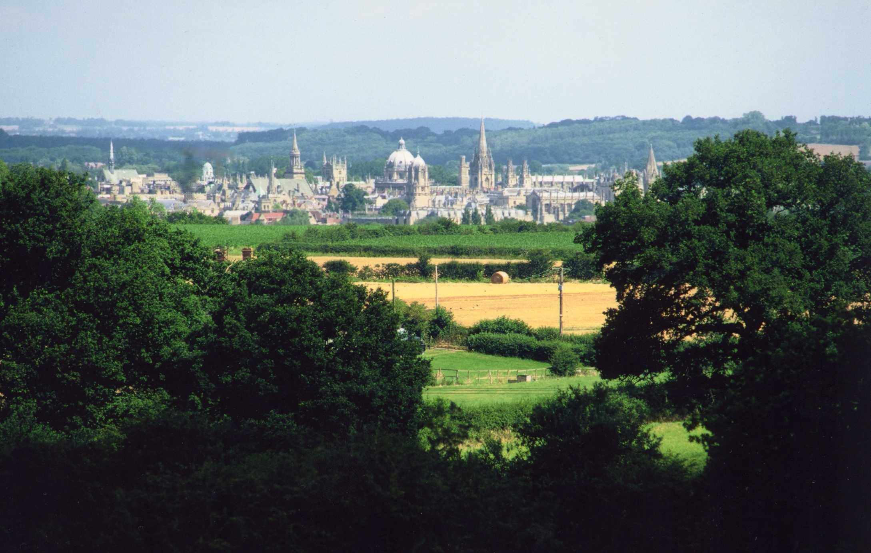

This is your county and we want to make it work for you.
We WILL LISTEN to your views and help to give you the county that you want.
We are proud of Oxfordshire and we want to conserve the best by preserving the historic sites of this famous University City, our charming market towns and our beautiful villages.
We want to protect our countryside, our Green belt and our farming industry which are national assets.
We want our City and towns to be welcoming and friendly to all.
We want a real choice of transport. We want our local economy to thrive.
We want to encourage shoppers and visitors to explore our unique heritage, to visit our shops, restaurants, theatres and other attractions with easy access.
We want our streets to be attractive and the air we breathe to be clean. We want people to feel secure.
We want sufficient affordable housing for our residents.

