OXFORDSHIRE SUPPORTING PEOPLE STRATEGIC REVIEW OF COMMUNITY ALARMS
COMMUNITY ALARM SUPPLY AND AREAS OF DEPRIVATION FOR OLDER PEOPLE

Maps showing Income Deprivation Affecting Older People in South Oxfordshire shows there is a lightly populated area between Sandford-on Thames and Berinsfield, running around the eastern borders of Abingdon which has a high proportion of People aged 65 and over who are affected by income deprivation, attached there is also a map covering the same area but showing density of people aged 65 and this shows that this area also has a high density of People aged 65 and over. This indicates that there may be unmet need in this particular area. District wide the maps show 21 small pockets of high percentage levels of people aged 65 and over in their population; this indicates the possibility of district wide need or demand for alarms spread out across a rural area. Provision for this demand will present difficulties associated with staffing and travel. There is therefore a significant mismatch between the presenting need and the available supply of provision in South Oxfordshire.

In other districts there is a good match of SP funded community alarms. It is clear that there are large areas of Oxfordshire of a rural nature with a high proportion of older people.

Community Alarms

The maps which follow for each district are shaded according to the proportion of households which are older people on low income compared within Oxfordshire.

Each district is shown divided into “Super Output Areas”, which are smaller than local government wards.

Older people means people aged 60 or over.

Areas in darkest blue are those with the highest proportion of households which are older people on low incomes.

Cherwell District Council

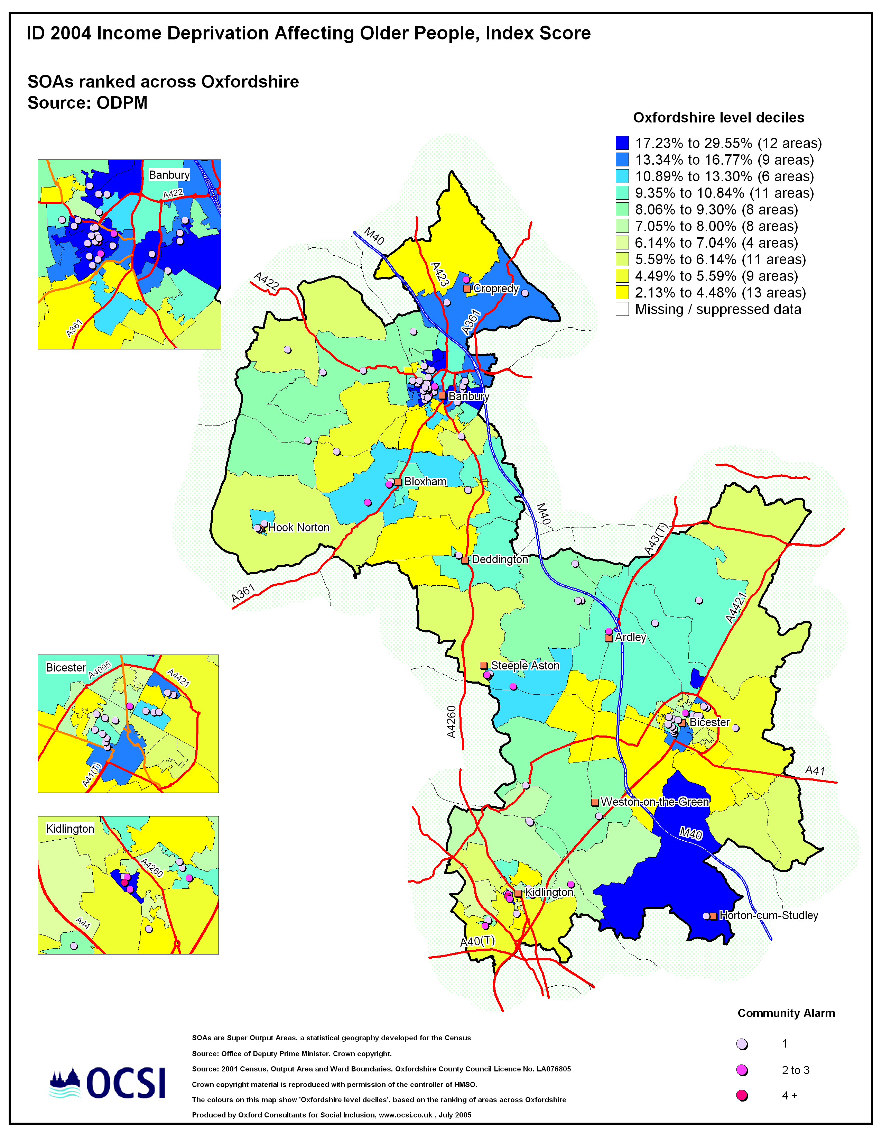

Oxford City

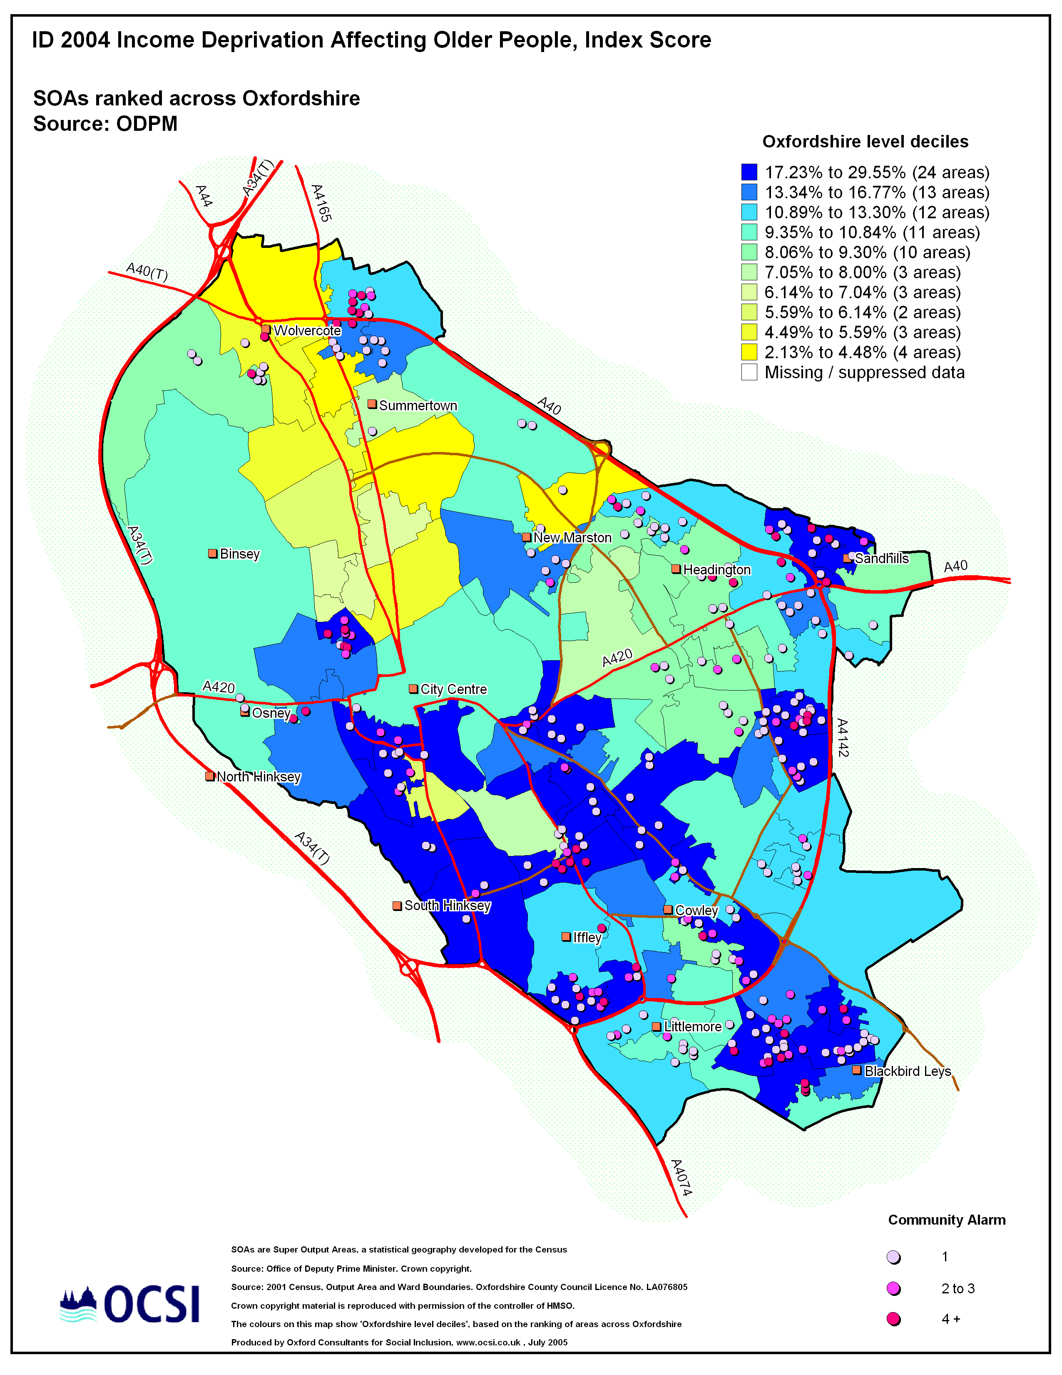

South Oxfordshire (Note: There are no SP-funded community alarms in this district)

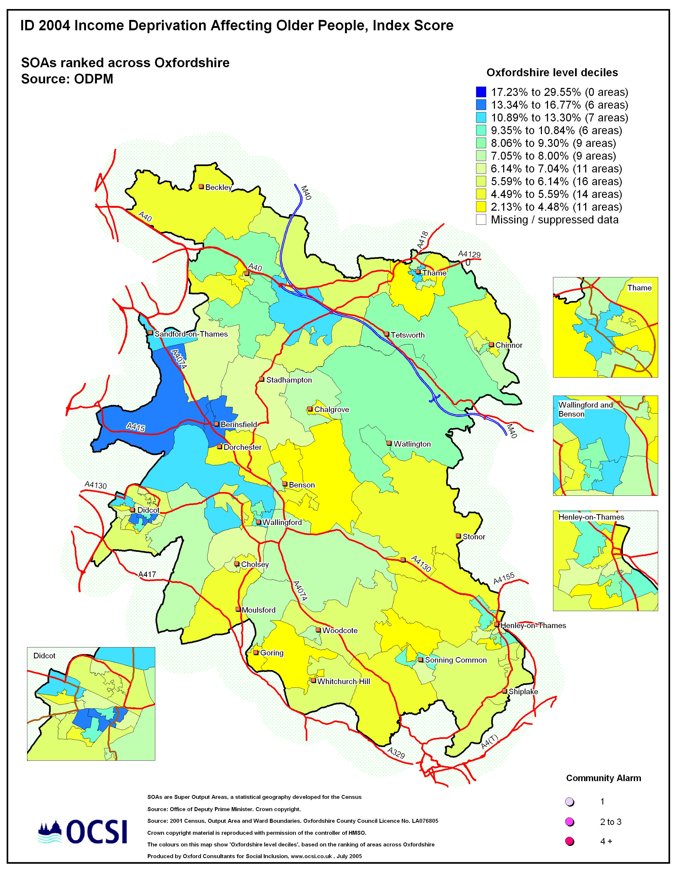

Vale of White Horse

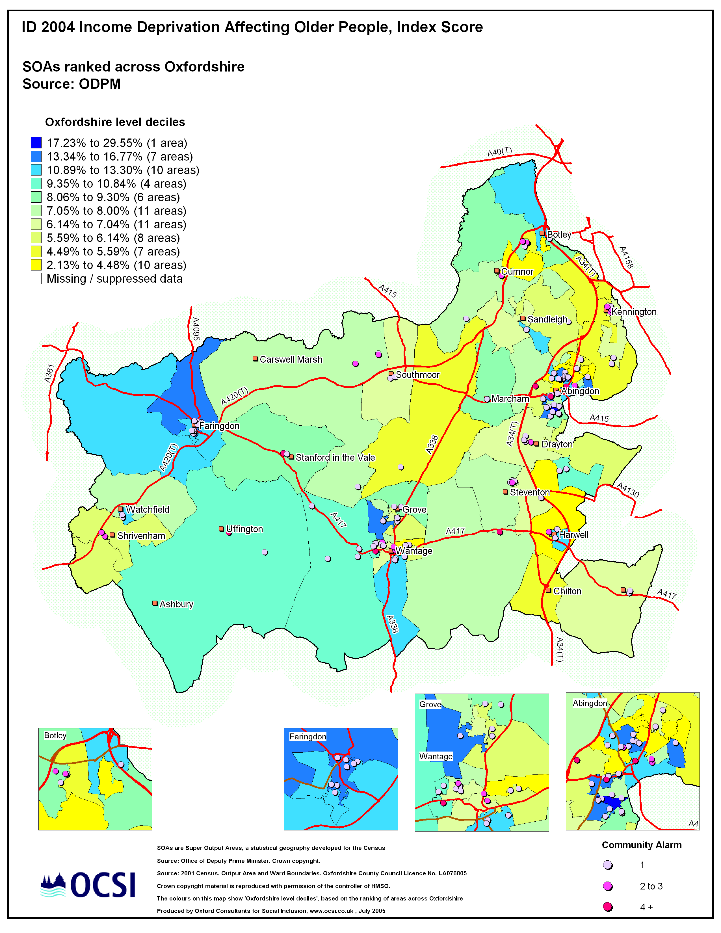

West Oxfordshire

