Division(s): N/A

ITEM CA8

CABINET – 21 OCTOBER 2008

REPORT ON THE PROPERTY PORTFOLIO 2007-08

Report by Head of Property

Introduction

- This is the annual report detailing the performance of the Council’s property portfolio from April 2007 to March 2008. The content of this report will help inform the Corporate Asset Management Plan.

- This year’s report includes benchmarking information and targets for 2008/09.

Fitness for Purpose

- The fitness for purpose results are used to inform the review of the Corporate Asset Management Plan, to inform property reviews and decisions on investment in property, to monitor changes in the property portfolio and to help prioritise action.

- Fitness for purpose surveys were undertaken for the majority of operational non-school Council properties in 2005/06 and 2006/07. Schools are excluded from this assessment because they are already subject to suitability and sufficiency assessments as required by DCSF. Last year Cabinet agreed to the recommendation that these surveys should be repeated every three years. Therefore the surveys were not repeated in 2007/08 and will be undertaken again in 2009/10.

- The findings for the Council’s operational property portfolio (excluding schools) for 2005/06 and 2006/07 were:

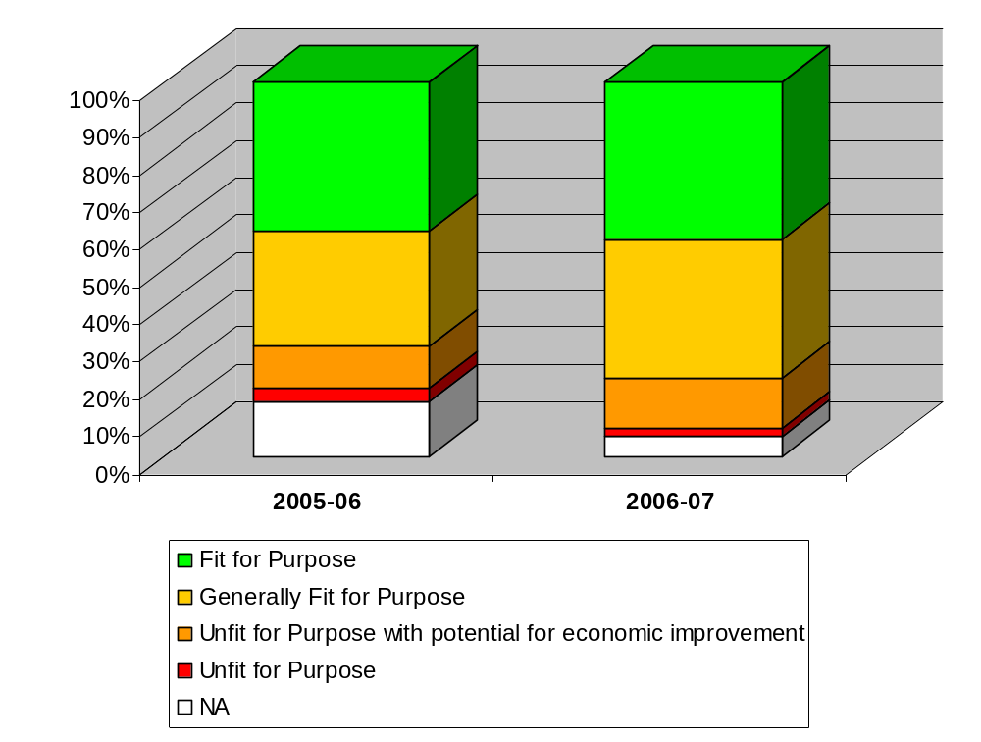
11% (48)
15% (64)
13% (56)
5% (22)
2% (10)
4% (16)
39% (172)
31% (135)
43% (176)
37% (155)
- The following targets represent the pro-rata progress needed to achieve the target of 90% of properties fit for purpose by 2015:

Year | 2006-07 | 2007-08 | 2008-09 | 2009-10 | 2010-11 | 2011-12 | 2012-13 | 2013-14 | 2014-15
Target | 44.7% | 48.9% | 54.8% | 60.6% | 66.5% | 72.4% | 78.3% | 84.1% | 90.0%
Actual | 43% | - | - | - | - | - | - | - | -

- Many of the schemes already within the Capital Programme, the Repairs and Maintenance Programme, the Access Programme and energy schemes will address fitness for purpose issues. In addition, the implementation of the Better Offices Programme will increase the number of Fit for Purpose offices from 20% to 60%. The Better Offices Programme is progressing on programme with new, fit for purpose offices now established in east Oxford (Knights Court) and the southern area (Windrush Court) with the disposal of poor quality office accommodation at Tyndale House (Cowley Road), Crown House (Cowley Road), Yarnton House (Yarnton) and 61a High Street (Wallingford).

- The 10 properties in the worst performing ‘unfit for purpose’ category in 2006/07 and action being taken are listed in Annex 1.

Size of the Portfolio and Capital Receipts

 | Number of main properties | Land area (freehold) | Land area (leased in) | Land area (leased/sublet out) | GEA of the property portfolio (used for Mouchel contract)
March 2008 | 843 | 1120.7ha | 207.2ha | 501.7ha | 1,079,037m²
March 2007 | 849 | 1184.5ha | 233.7ha | 534.4ha | 1,062,466m²
March 2006 | 835 | 1197.4ha | 255.8ha | - | -
March 2005 | 840 | - | - | - | -

 | No. of freehold acquisitions | No. of freehold disposals
2007-08 | 10 | 21
2006-07 | 9 | 13
2005-06 | 12 | 20
2004-05 | 4 | 19

CAPITAL RECEIPTS 2007-08
Directorate | Capital Receipts
Children, Young People & Families | £1,686,450
Environment & Economy | £40,920
Corporate Core | £4,996,600
Social & Community Services | £1,580,000
Community Safety | £0
TOTAL | £8,303,970

ESTIMATED CAPITAL RECEIPTS 2008-09 (as at 1st April 2008)
Directorate | Capital Receipts
Children, Young People & Families | £3,666,200
Environment & Economy | £284,500
Corporate Core | £5,741,905
Social & Community Services | £9,368,250
Community Safety | £295,000
TOTAL | £19,355,855

- Gross capital receipts received from property and land sales for the year 2007/08 were £8.3m compared to a target of £12.2m at the start of the year and £13.72m in 2006/07. A total of 21 sites/properties were disposed of. The shortfall was due to the failure of 8 disposals identified at the start of the year to complete within the year, two of which were significant in terms of the receipt due (Witan House, £2.5m; Lawn Upton School, £1.2m from a sale by the Diocese).

- Approximately 60% of the receipts came from corporate property with the sale of Yarnton House and 61 High Street, Wallingford as part of the Better Offices Programme achieving £3.6m and £630,000 respectively. Properties formerly used by CYP&F directorate contributed £1.686m of which the former Nettlebed School achieved £1.35m. The sale of the former care home, Holme Leigh, generated £1.58m from property formerly used by S&CS directorate.

- Land and property acquisitions during the year were limited to minor highway improvements (Skimmingdish Lane, Bicester and Abingdon town centre), a site at Tramway Road, Banbury for the development of the new Banbury office under the Better Offices Programme and Oakley Wood, Wallingford, a waste reception facility. Further details of acquisitions and disposals are provided in Annex 2.

- The estimated capital receipt of £19.4m as at 1 April 2008 for 2008/09 includes Shotover Centre, however it is now intended that the site will be retained for extra care housing. The property has therefore been taken out of the disposal programme for 2008/09.
Condition and Required Maintenance

Condition and required maintenance data for 2007/08 in comparison to previous years is provided below.

(i) Percentage gross internal floor space in condition categories A-D (non-school property):

Note: As of 2005-06, this indicator includes non-operational properties which were not included in previous years. Schools will be included in future years as overall condition ratings for school properties become available.

A – Good: performing as intended and operating efficiently
B – Satisfactory: performing as intended but showing minor deterioration
C – Poor: showing major defects and/or not operating as intended
D – Bad: life expired and/or serious risk of imminent failure

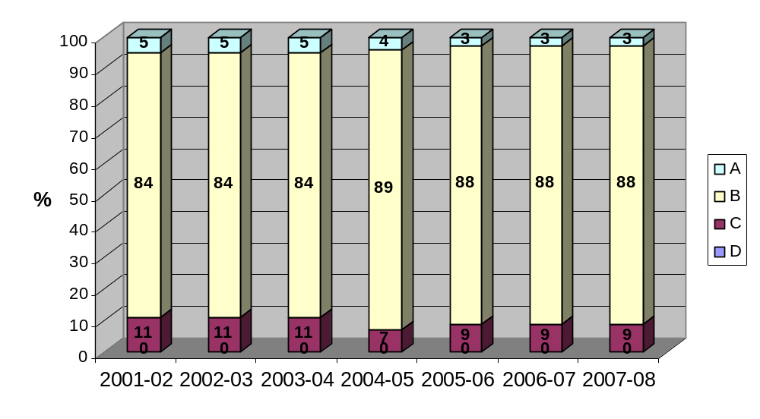
(ii) Required maintenance by cost expressed as total cost/percentage in priority levels 1-3 and as overall cost per m² GIA:

Note: As of 2005-06, this indicator is required to include schools which were not included in previous years.

Priority 1 – urgent works that will prevent immediate closure of premises and/or address an immediate high risk to the health and safety of the occupants and/or remedy a serious breach of legislation.
Priority 2 – essential work required within two years that will prevent serious deterioration of the fabric or services and/or address a medium risk to the health and safety of the occupants and/or remedy a minor breach of the legislation.
Priority 3 – desirable work required within 3-5 years that will prevent deterioration of the fabric or services and/or address a low risk to the health and safety of the occupants and/or a minor breach of the legislation.

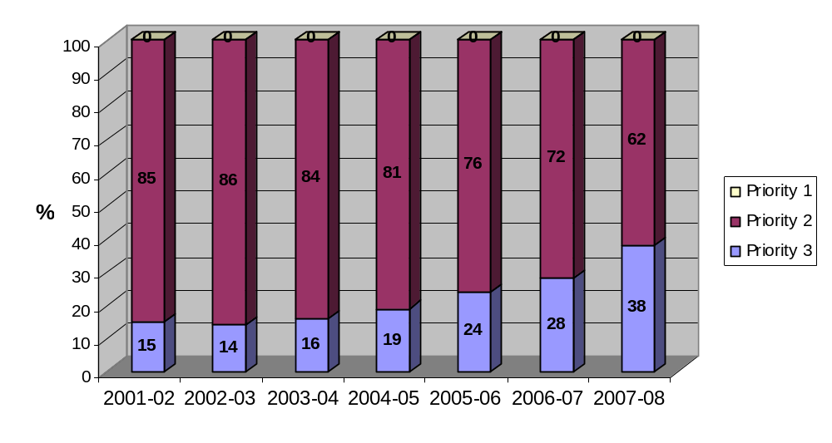

 | Priority 1 | Priority 2 | Priority 3 | Total | Cost/m² GIA
Target 2008-09 | £0 (0%) | £51,258,606 (70%) | £21,967,973 (30%) | £73,226,579 (100%) | £80.85
2007-08 | £0 (0%) | £45,962,079 (62%) | £28,379,625 (38%) | £74,341,704 (100%) | £82.08
Target 2007-08 | £0 (0%) | £53,773,276 (70%) | £23,045,691 (30%) | £76,818,967 (100%) | £86.08
2006-07 | £0 | £56,332,884 | £21,686,083 | £78,018,967 | £87.42
2005-06 | £0 | £60,106,883 | £19,061,643 | £79,168,526 | £90.45
2004-05 | £1,000 | £6,862,000 | £1,595,150 | £8,458,150 | NA
2003-04 | NA | NA | NA | NA | NA
2002-03 | NA | NA | NA | £10,991,550 | NA
2001-02 | NA | NA | NA | £10,169,320 | NA

(iii) Annual percentage change to total required maintenance figure over previous financial year (including schools):

 | Total required maintenance | Target % change over previous financial year | Actual % change over previous financial year
2008-09 | - | -1.5% | -
2007-08 | £74,341,704 | -1.5% | -4.7%
2006-07 | £78,018,967 | - | -1.0%
2005-06 | £79,168,526 | - | -5.2%
2004-05 | £83,482,680 | - | -

(iv) Total spend on maintenance:

Note: As of 2005-06, this indicator is required to include schools which were not included for previous years. The data is inclusive of schools’ delegated maintenance spend. Capital Prudential funding is excluded from the indicator.

 | Total spend on maintenance | Total spend on maintenance per m² GIA | % split of total spend on maintenance
 | Total spend on maintenance | Total spend on maintenance per m² GIA | Planned | Responsive
Target 2008-09 | £10,576,156 | £11.68 | 60% | 40%
2007-08 | £11,391,994 | £12.58 | 47% | 53%
Target 2007-08 | £9,678,800 | £10.85 | 60% | 40%
2006-07 | £9,936,238 | £11.13 | 56% | 44%
2005-06 | £9,327,484 | £10.66 | 51% | 49%
2004-05 | £2,941,047 | £21.81 | NA | NA
2003-04 | NA | £20.86 | NA | NA
2002-03 | NA | £19.32 | NA | NA
2001-02 | NA | £20.96 | NA | NA

(v) Programmed repair and maintenance works

Percentage of programmed works completed by completion date
2007-08 | 100%
2006-07 | 100%

- The data above indicates a progressive improvement in the condition of the Council’s property portfolio. The figures shown have not been adjusted to a common price base but if they were, the overall reduction in required maintenance would be more marked.

- The percentage of property in condition categories A-D in (i) above has been consistent for the last 3 years. This is partly because assessed need surveys are only undertaken for one third of the portfolio in any one year but also because the definitions of categories A-D are relatively broad and subjective.

- This reduction in the value of required maintenance is attributable to a range of investment initiatives and funding strategies including Prudential Borrowing investment in repairs, the capital programme, devolved formula capital and developer funding investment in the refurbishment of schools, the replacement of some temporary classrooms with new school buildings and the replacement of other properties funded from capital receipts.

- Benchmarking information on condition and repair and maintenance is provided in Annex 3.

Environmental Performance

Environmental performance data for 2007-08 is provided below:

(i) Percentage of all properties (with available data) in environmental performance categories 1-4

1 – Better than good practice benchmark
2 – Consumption above good practice benchmark but better than typical
3 – Consumption above typical by up to 25%
4 – Consumption above typical by more than 25%

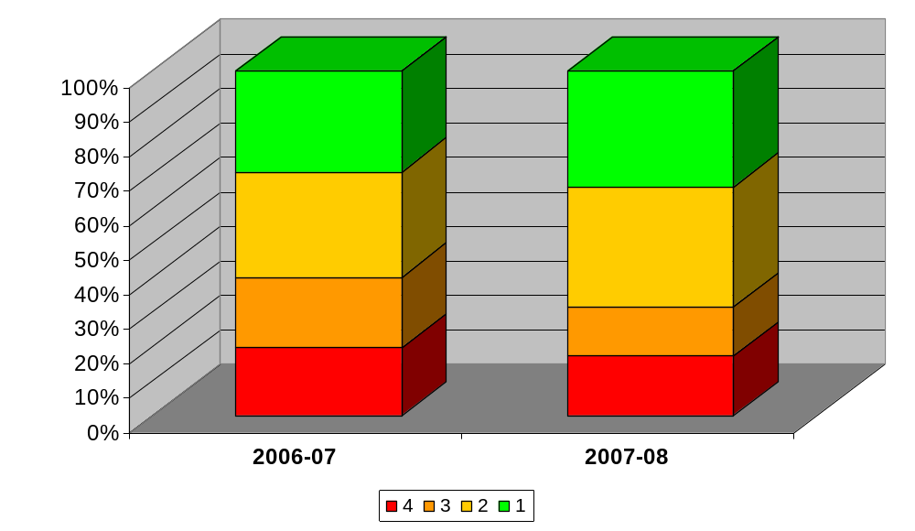
34% (147)
35% (151)
14% (62)
17% (75)
29% (126)
31% (131)
20% (88)
20% (85)

(ii) Energy consumption in kWh/m² by property type with typical and good practice benchmarks

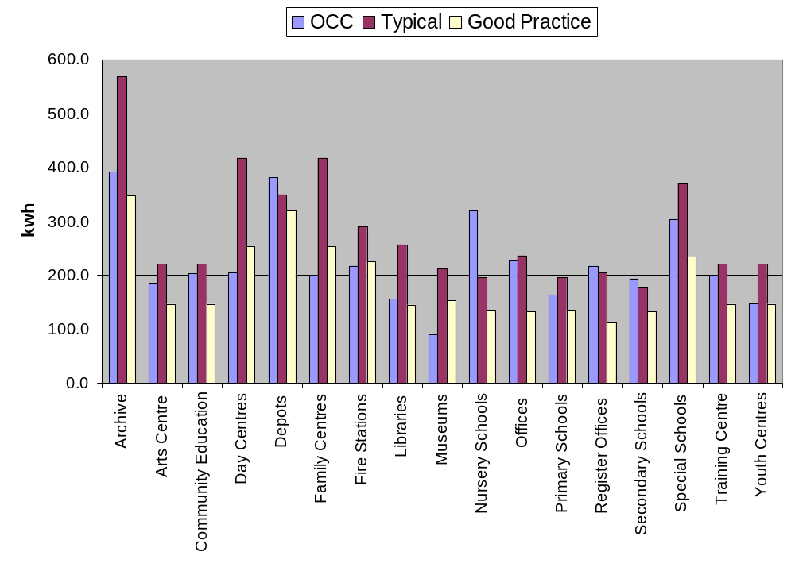

- The first chart above indicates that 69% of properties perform better than typical (i.e. average, based on benchmarks for various property types) in terms of carbon dioxide (CO₂) emissions arising from energy and water use. Conversely, 17% of properties have CO₂ emissions that are at least 25% higher than typical for the type of building. This is slight reduction on the previous year.

- The second chart above shows the average energy use across various property categories, compared to good practice benchmarks and typical (average) values for such properties. It indicates that whilst for most property categories, average energy use for County Council properties is between good practice and typical, there continue to be two groups (depots and nursery schools) which have higher energy use. The small sample size for some categories (e.g. Register Offices) makes the comparison less reliable. The energy management service from our core property consultant, Mouchel, focuses efforts on the worst performing sites in order to understand the reasons for this and to identify measures that could be implemented to improve the situation. These could relate to building fabric, services issues or site management practices.

- Carbon dioxide emissions during 2007/08 were 18% lower than 1990-91. Since 2005/06 (the benchmark year for the Carbon Management Programme), emissions have decreased by 5%.

- The Carbon Management Strategy & Implementation Programme was developed in 2006/07 and delivery commenced during 2007/08. A significant element of this programme relates to the use of Salix funds (joint Carbon Trust and County Council funding) and these were fully committed during the year; lighting upgrades and voltage reduction equipment were the two major areas of spend. Supplementing the Salix funds is Prudential borrowing. It continues to be difficult to fully commit the Prudential funds for a variety of reasons, including budget-holders’ reluctance to enter into agreements to repay the initial Capital costs from ongoing revenue savings. Various strategies have been applied to increase the take up of these funds.

- Two new energy supply contracts were entered into during 2007/08 – for gas and for half-hourly-metered electricity. Each of these resulted in significant reductions in prices for two years between autumn 2007 and autumn 2009. Since the time of agreement of these contracts, market prices have risen dramatically and it is anticipated that a major increase in prices will come into effect from the autumn of 2009. The electricity contract for non-half-hourly-metered sites has fixed prices for two years ending in autumn 2008. A significant price rise (approximately 40%) will take place at that time.

- Energy management is enhanced by good quality data on patterns of use. To this end, Carbon Management funds are being utilized to install automated monitoring & targeting systems (aM&T) for energy and water use at a number of sites. The obtained data can be used for technical analysis and is available to site managers and occupants for their use. It can also be a useful educational tool. The market for such systems is expanding rapidly and discussions are underway with energy suppliers to install aM&T systems across a wider range of properties. A recent Government requirement means that certain qualifying sites will have aM&T equipment installed to monitor electricity use at no cost to the end user.

- Display Energy Certificates (DECs; energy labels, similar to those on retail white goods) become a legal requirement on 1 October 2008 for sites above 1,000m² that are frequented by the public. A programme of production of DECs is underway, although, like other Authorities with a similar-size estate, the generation of these is likely to extend beyond 1 October. This is largely because the required software has only recently been released by Government and there are as yet very few qualified assessors. These certificates will raise the profile of energy use and carbon emissions with building managers and occupants and should increase the engagement in energy management activities.

(iii) CO₂ targets

TARGET | Reduction in total CO₂ emissions between 2005-06 and 2011-12 of 18%, which equates to a 3% annual reduction in total emissions (887 tonnes per annum).
Year | Target emissions (tonnes/annum) | Actual emissions (tonnes/annum) exclusive of renewables purchases
2011-12 | 33,521 | -
2010-11 | 34,747 | -
2009-10 | 35,974 | -
2008-09 | 37,200 | -
2007-08 | 38,426 | 38,840
2006-07 | 39,653 | 38,400
2005-06 | 40,879 | 40,879

- This target replaces previous targets for carbon dioxide (CO₂) emissions and energy use in light of the recently adopted emissions target for the Carbon Management Programme. The 18% target for property is the same as the overall target for emissions reduction across Council activities as detailed in the Carbon Management Strategy and Implementation Plan. It is almost certain that the reduction in CO₂ emissions from property will need to be at a higher rate than other areas where it will be more difficult to achieve the pro rata reductions.

- Achievement through 2007/08 was just behind target and slightly higher than 2006/07 which was a very warm year. Electricity use, in particular, has been increasing in recent years primarily because of the increasing level of ICT equipment employed. However, in 2007/08, electricity use decreased slightly from the previous year. It continues to be a focus because of its higher unit cost and CO₂ emissions. Various measures are being implemented in an effort to reduce its use, including:

- promoting and purchasing more efficient equipment and enabling lower-power options,
- encouraging and assisting building occupants to manage electricity use more effectively (e.g. switching off equipment and lights when not in use), and
- identifying and implementing capital projects such as those that improve efficiency of use or automate a switching off regime.
Building Accessibility (BVPI 156)

BVPI 156: Percentage of authority buildings open to the public in which all public areas are suitable for and accessible to disabled people

 | Target | Actual % of properties open to the public complying with BVPI 156
2007-08 | 89.74% | 89.74%
2006-07 | 72.15% | 70.51%
2005-06 | 68.00% | 69.62%
Note: Targets calculated using Building Regulations Approved Document M (1999)

 | Portfolio by GIA m² for which an Access Audit has been undertaken by a competent person
 | % | No.
2007-08 | 100 | 78
2006-07 | 100 | 78
2005-06 | 100 | 79
Note: Only buildings that are open to the public are required to have an Access Audit.

- The Council’s BVPI 156 return for 2007/08 indicated that 89.74% of Council buildings which are ‘open to the public’ met the Council’s chosen benchmark standard for measuring accessibility (Approved Document M (1999) of the Building Regulations) in comparison to 70.51% in 2006/07. This was in line with the Council’s target for 2007/08.

- The New National Indicator Set does not include an indicator for the accessibility of Council buildings ‘open to the public’. BVPI156 has been discontinued. Consideration is being given to the development of a local indicator for use in future years.

Utilisation of School Properties

Reported in the annual DCSF return | Schools with over 25% surplus spaces (and greater than 30 spaces in the case of primary schools) |  | Overall % of surplus spaces
Reported in the annual DCSF return | Primary | Secondary | Primary | Secondary
2008 | 8.6% (20 of 232 schools) | 9% (3 of 33 schools) | 8.6% | 11%
2007 | 6.4% (15 of 233 schools) | 6% (2 of 34 schools) | 10% | 10%
2006 | 9% (22 of 233 schools) | 3% (1 of 34 schools) | 12.45% | 10.76%

- Each year the Authority completes a statement on the supply of school places in the primary and secondary sectors for submission to DCSF. It is used to determine efficiency of provision of school places and to assess future basic need allocations. County Council policy is to have an average of 10% overall surplus spaces in schools to allow for necessary flexibility. On this basis, primary schools are meeting target in 2008; secondary schools are just off target but with measures in place to deal with this.

- The increase in the number of primary schools with in excess of 25% surplus places is due to three main reasons: schools located within catchment areas including military bases; small rural schools which are more sensitive to local fluctuations in the population; and schools in Bicester, where significant growth is expected in future. Overall numbers on roll in primary schools had been falling but are now beginning to rise again in most districts.

- Of the three secondary schools with over 25% surplus spaces, Peers Technology College is to become an academy in September 2008. Banbury School is in an area of large future growth and a strategic plan for the site is in place. Demand for spaces at Chiltern Edge School has been low but is improving.

Capital Projects

- The national performance indicator definitions for cost and time predictability of capital projects have been revised for 2007/08. The new indicators split projects into the design (feasibility) phase and the construction phase rather than considering the project as one phase from start to completion, as in previous years. For this reason it is not possible to compare performance in 2007/08 against target, although the introduction of the new indicator definitions enables targets to be set for 2008/09.

- The national performance indicators reported here require that cost and time predictability is within 5%. Where relevant these are contrasted with the Contract performance indicators which require different percentage accuracies.

(i) Cost Predictability (Feasibility)

FEASIBILITY | Capital Projects where the cost at Contract Let is within +/- 5% of the cost predicted at Project Appraisal
FEASIBILITY | % | Number
Target 2008-09 | 50% | -
2007-08 | 17.4 % | 4 / 23

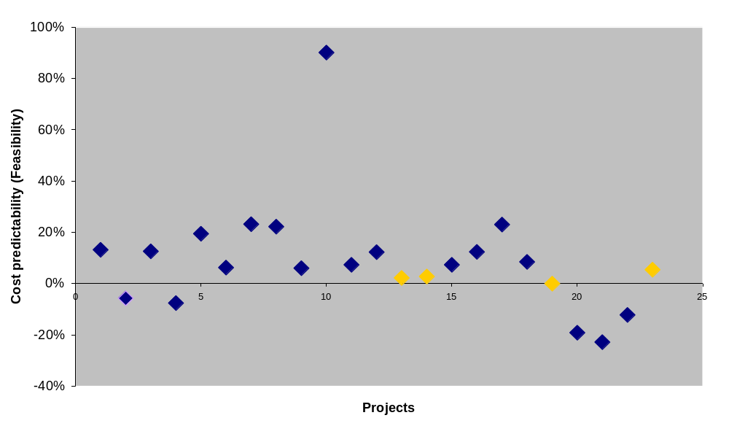

- The chart above illustrates cost predictability at feasibility stage. The Contract performance indicators require consultants to be within an accuracy of +/- 20% comparing initial estimate with final project cost. The chart shows that consultants are generally under estimating and this demonstrates the need for greater accuracy or a higher level of contingency within cost estimates at this stage. 78% of estimates were within +/- 20%. The national performance indicator margin of +/- 5% at this stage of scheme development is very tight and as a consequence it is considered that a target of 50% is appropriate for next year.

(ii) Cost Predictability (Construction)

CONSTRUCTION | Capital Projects where the cost at Practical Completion is within +/- 5% of the cost predicted at Contract Let
CONSTRUCTION | % | Number
Target 2008-09 | 80% | -
2007-08 | 70.0 % | 14 / 20

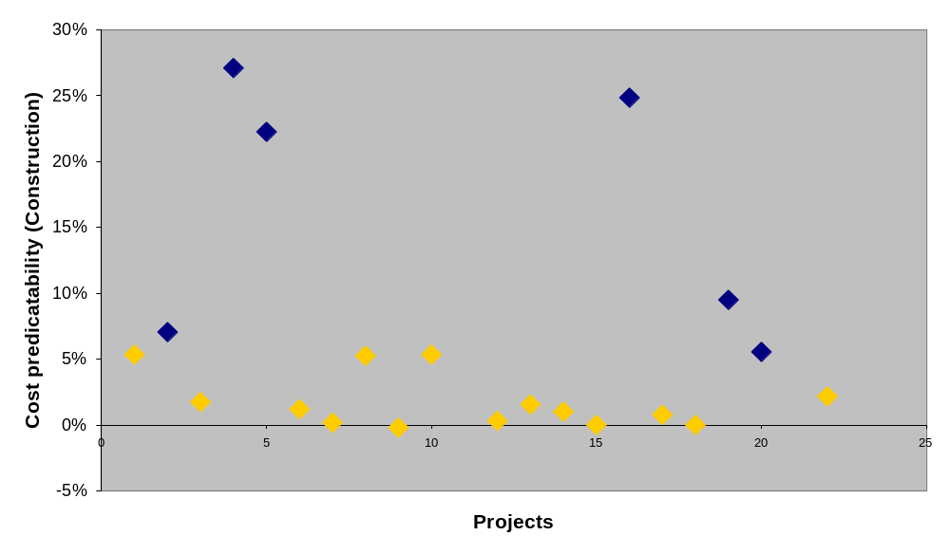

- The chart above illustrates cost predictability at construction stage. The Contract performance indicators require consultants to be within an accuracy of +/- 10% comparing contract let with final project cost. 85% were within this target. The chart shows that consultants are not including sufficient provisions for unforeseen works and/or provisions for incomplete design. The intention is to seek higher standards in the completion of designs at tender stage and to gain better understanding of risks thereby including appropriate levels of contingency within contracts at this stage. It is considered that a target of 80% is appropriate for next year.

(iii) Time Predictability (Feasibility)

DESIGN | Capital Projects where the design period is within, or not more than 5% above, the time predicted at Project Appraisal
DESIGN | % | Number
Target 2008-09 | 60% | -
2007-08 | 43.5 % | 10 / 23

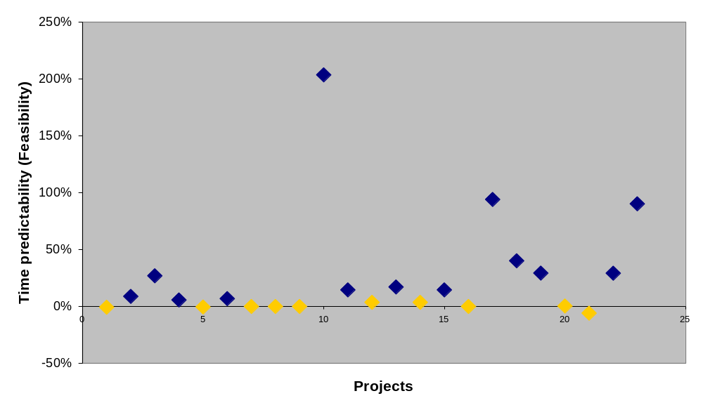

- The chart above illustrates the time predictability at feasibility stage. The chart shows that consultants are generally under estimating the time taken during the design stage and this demonstrates the need for greater focus on delivery and/or a higher level of contingency within project programmes at this stage; it is often the case that design teams will endeavor to be optimistic and do not generally seek to include provisions for unforeseen delays such as protracted planning negotiations and the like. It is considered that a target of 60% is appropriate for next year.

(iv) Time Predictability (Construction)

CONSTRUCTION | Capital Projects where the construction period is within, or not more than 5% above, the time predicted at Contract Let
CONSTRUCTION | % | Number
Target 2008-09 | 60% | -
2007-08 | 35 % | 7 / 20

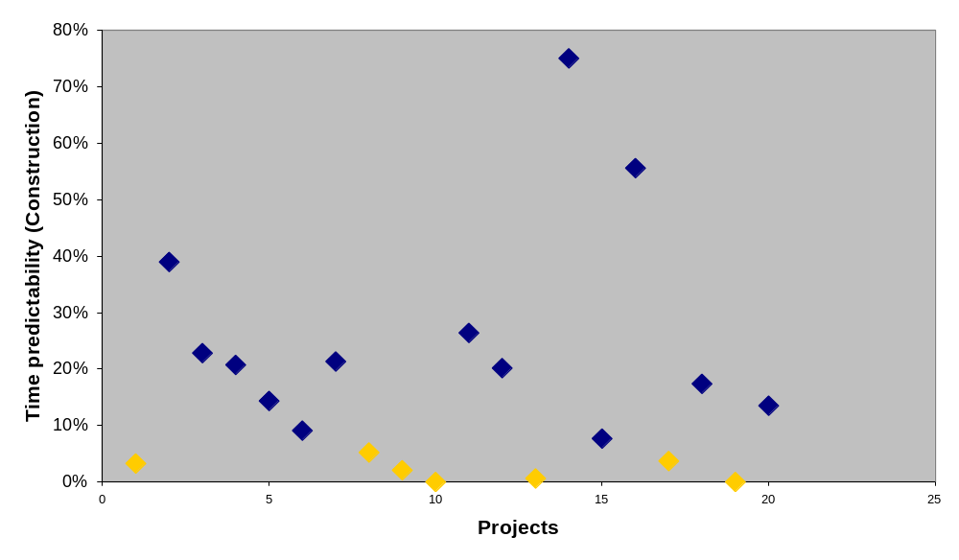

- The chart above illustrates time predictability at construction stage. The chart shows that contractors are generally taking longer to construct than anticipated. This may be for a number of reasons and does not take account of extended contract completion dates which may arise through delays outside the control of the contractor, such as exceptionally inclement weather, increased scope of works, delays by statutory authorities etc. There are however influences within the control of the consultants such as completeness of the design and delivery of information in a timely manner. It is considered that a target of 60% is appropriate for next year.

RECOMMENDATIONS

- The Cabinet is RECOMMENDED, subject to consideration of the comments of the Corporate Governance Scrutiny Committee, to note the report.

NEIL MONAGHAN
Head of Property
Environment & Economy

Background papers: Nil

Contact Officer: Mark Tailby, Assistant Head of Property Tel (01865) 816012

September 2008

ANNEX 1
Unfit for purpose properties and action being taken

Ref. | Establishment Name | Tenure | Action
10078 | Banbury Library | Leased in by OCC | Funding allocated in Capital Programme
13983 | Chipping Norton Library | Owned by OCC | Consideration being given to replacement library being provided as part of a housing development.
11197 | Headington Library | Leased in by OCC | Negotiations have continued with the City Council to establish a solution which meets accessibility and listed building criteria and is affordable and suitable for the service. A draft planning application for works needed to the listed building is due to be submitted to English Heritage and the City Council imminently. Completion is due October 2009.
10062 | 25/27 West Bar, Banbury | Owned by OCC | Option appraisal for replacement being undertaken.
14349 | Witney Day Centre (The Elms) | Owned by OCC | Scheme being progressed to relocate to Moorview, Witney. Due to complete February 2009.
13376 | Ridgeway Volunteer Hostel (Store), Wantage | Leased in by OCC | Project underway to consolidate Countryside Service accommodation. Funding allocated in capital programme.
11607 | Oakley Wood Traveller Site | Owned by OCC | Site purchased to secure long term future. Planning application for improvements approved.
13999 | Castle View Elderly Persons Home | Owned by OCC | Replacement is proposed as part of the new care home and PCT facility on the Rockhill Farm site, which is due to start on site in October 2008 with completion in early 2010.
10145 | Greenwood Centre Offices | Owned by OCC | To be replaced as part of the Better Offices Programme by December 2009.
12612 | Wallingford Youth Centre | Owned by OCC | Replacement planned. Funding from capital receipt and capital programme allocation. Due to complete December 2009.

ANNEX 2
Disposals and acquisitions

FREEHOLD DISPOSALS 2007-08
Description | Location
52 Springfield Avenue (Right to Buy) | Banbury
Land at Bicester Community College sale to CDC | Bicester
Land at Musgrave Road, sale to adjoining owner | Chinnor
52 The Avenue Kennington (Right to Buy) | Oxford
Playing Field to former Letcombe Regis School | Letcombe Regis
Former Nettlebed Primary school | Nettlebed
Small area of Land St. Thomas’ Street | Oxford
Land in Cherwell Street | Banbury
Land adjacent to Mistral | Ducklington
Land at Watchfield | Shrivenham
Former Highways Depot | Tiddington
Land at white House Farm | Aston
New Glebe Farm | Black Bourton
Release of restrictive covenant | Blackthorn
29 Mereland road - former staff house | Didcot
Land at Chilbridge Road | Eynsham
Land adjacent to Spring Cottage | Milton under Wychwood
Land at Stanton St John | Stanton St john
Yarnton House | Yarnton
61a High Street | Wallingford
Holme Leigh | Oxford
TOTAL | 21

FREEHOLD ACQUISITIONS 2007-08
Description | Location | Purpose
1225 sq.m for sports & education purposes | Milton Heights | School Development
180 sq.m of land Skimmingdish Lane | Bicester | Highway
1896 sq.m of land Skimmingdish Lane | Bicester | Highway
Land from Vale of White Horse District Council | Abingdon | Highway
Land from Oxford City | Oxford | Highway
Land to the rear of 1b Crawley Road | Witney | Highway
Site at Tramway Road | Banbury | Office development
Approximately 28.3 ha Oakley Wood | Wallingford | Waste Recp. Centre
Drainage Easement | Carterton | Highway
Moorview | Witney | Adult Res. Centre
TOTAL |  | 10

ANNEX 3
Benchmarking

The following benchmarking data is provided by the Institute of Public Finance (IPF). Data for 2007/08 is not yet available at the time of writing, therefore Oxfordshire County Council’s figures for 2007/08 are compared with 2006/07 figures from other county councils. Benchmarking data is used to assess performance against other county councils and to set targets for future years.

Condition and Required Maintenance

(ii) Required maintenance as overall cost per m² GIA:

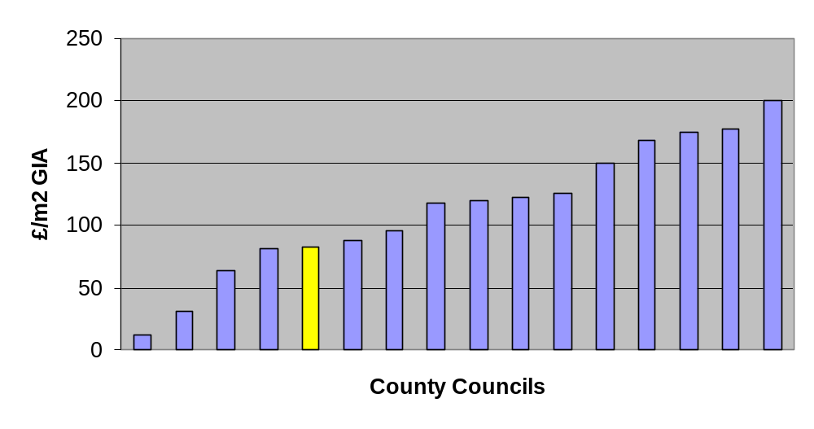
OCC
The IPF data should be considered with caution as individual authorities’ definitions of ‘required maintenance’ may differ. However, the data does suggest that the Oxfordshire County Council stock is in better than average condition when compared with the stock held by the other authorities that participated in the survey.

(iv) Total spend on maintenance per m² GIA:
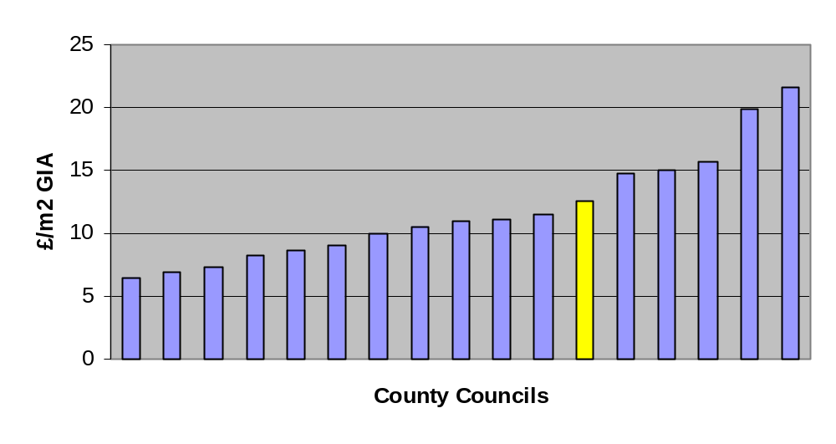
OCC
This data indicates that the Council’s spend per m² of GIA is about average compared with the other authorities that participated in the survey. However, when the Council’s Prudential Borrowing investment in repair and maintenance ends in 2010/11 total spend on planned repair and maintenance will fall significantly.

(iv) Percentage split of total spend on maintenance:
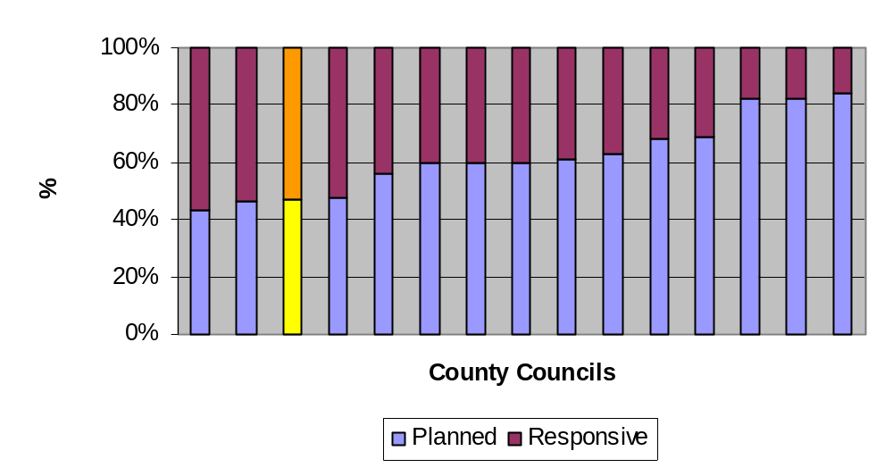
OCC

The Council is still spending more on relatively poor value day to day responsive repair and maintenance than it should be. This is a legacy of the under-funding of repair and maintenance during the 1990s and the early part of this decade. Ideally the Council should be spending at least two thirds of its budget for repair and maintenance on pro-active planned repair and maintenance. This can only be achieved by maintaining current levels of investment.

Building Accessibility (BVPI 156)

(i) BVPI 156: Percentage of authority buildings open to the public in which all public areas are suitable for and accessible to disabled people

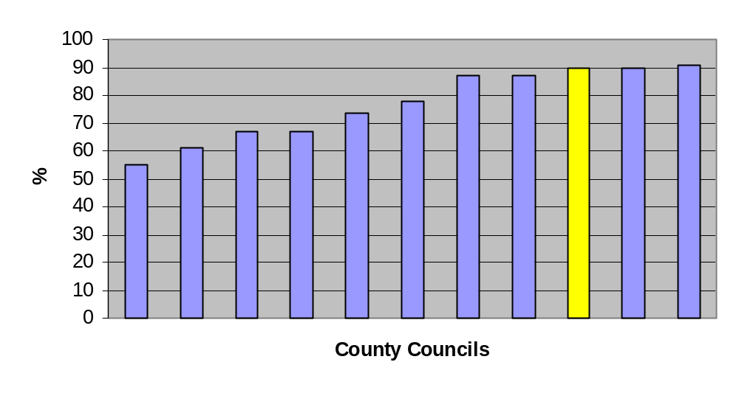
OCC
The recent capital investment in access improvements to buildings ‘open to the public’ has significantly improved the Council’s BVPI score compared with other local authorities. Publicly accessible areas of 89.74% of these buildings now comply with Part M (1999) of the Building Regulations.

